



Report WP4-A1:
A survey of the known AI techniques and methods from the point of view of the selected database
Funded by the European Union. Views and opinions expressed are however those of the author(s) only and do not necessarily reflect those of the European Union or the European Education and Culture Executive Agency. (EACEA). Neither the European Union nor EACEA can be held responsible for them.

Result
A report documenting the analysis of existing AI techniques and models.
Related to
WP4-A1: A survey of the known AI techniques and methods from the point of view of the selected database
Statement of originality
This report contains original unpublished work, except where clearly indicated otherwise. Acknowledgement of previously published material and of the work of others has been made through appropriate citation, quotation, or both.
Disclaimer
This report contains material, which is the copyright of TAI Consortium Parties. All TAI Consortium Parties have agreed that the content of the report is licensed under a Creative Commons Attribution Non-Commercial Share Alike 4.0 International License. TAI Consortium Parties does not warrant that the information contained in the Report is capable of use, or that use of the information is free from risk and accept no liability for loss or damage suffered by any person or any entity using the information.

Copyright notice
© 2024-2027 TAI Consortium Parties

Note
For anyone interested in having more information about the project, please see the website at: https://tai-erasmus.eu/

This publication is licensed under a Creative Commons Attribution-NonCommercial 4.0 International Public License (CC BY-NC 4.0).

Document version history

Version | Date | Author | Comment
1.0 | 23.07.2026. | Mirza Pašić, UNSA | Initial version

Table of contents

1. Introduction and purpose of the analysis 27
2. Sample and respondent profile 27
3. Relevance of problem types across data modalities 28
4. Tabular data 28
4.1 Regression 28
4.2 Classification 29
4.3 Time series prediction 30
4.4 Clustering and segmentation 30
5. Image data 31
6. Audio data 32
7. Video data 33
8. Priority of teaching modules 33
9. Level, teaching materials and tools 34
10. Open-ended suggestions 35
11. Recommendations for the development of the TAI modules 36
Appendix - Questionnaire 37
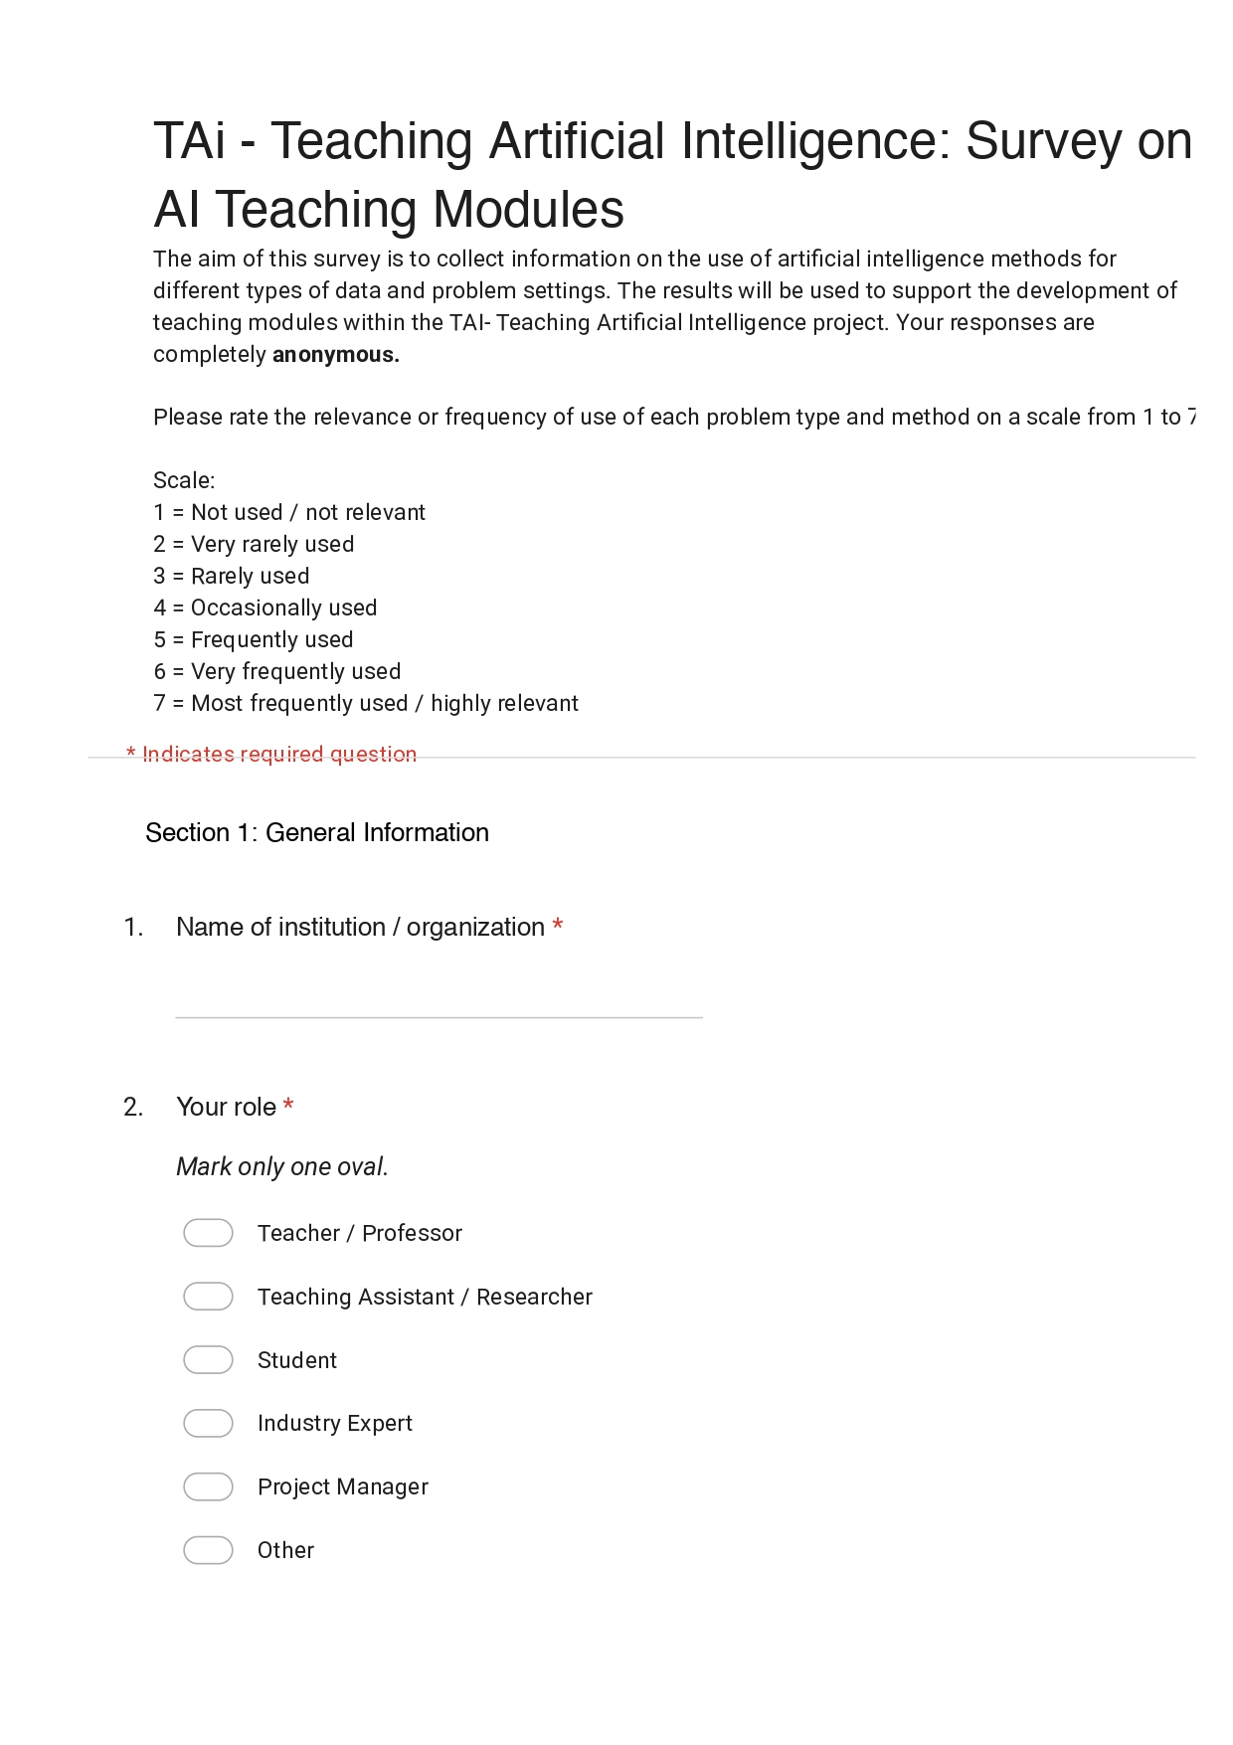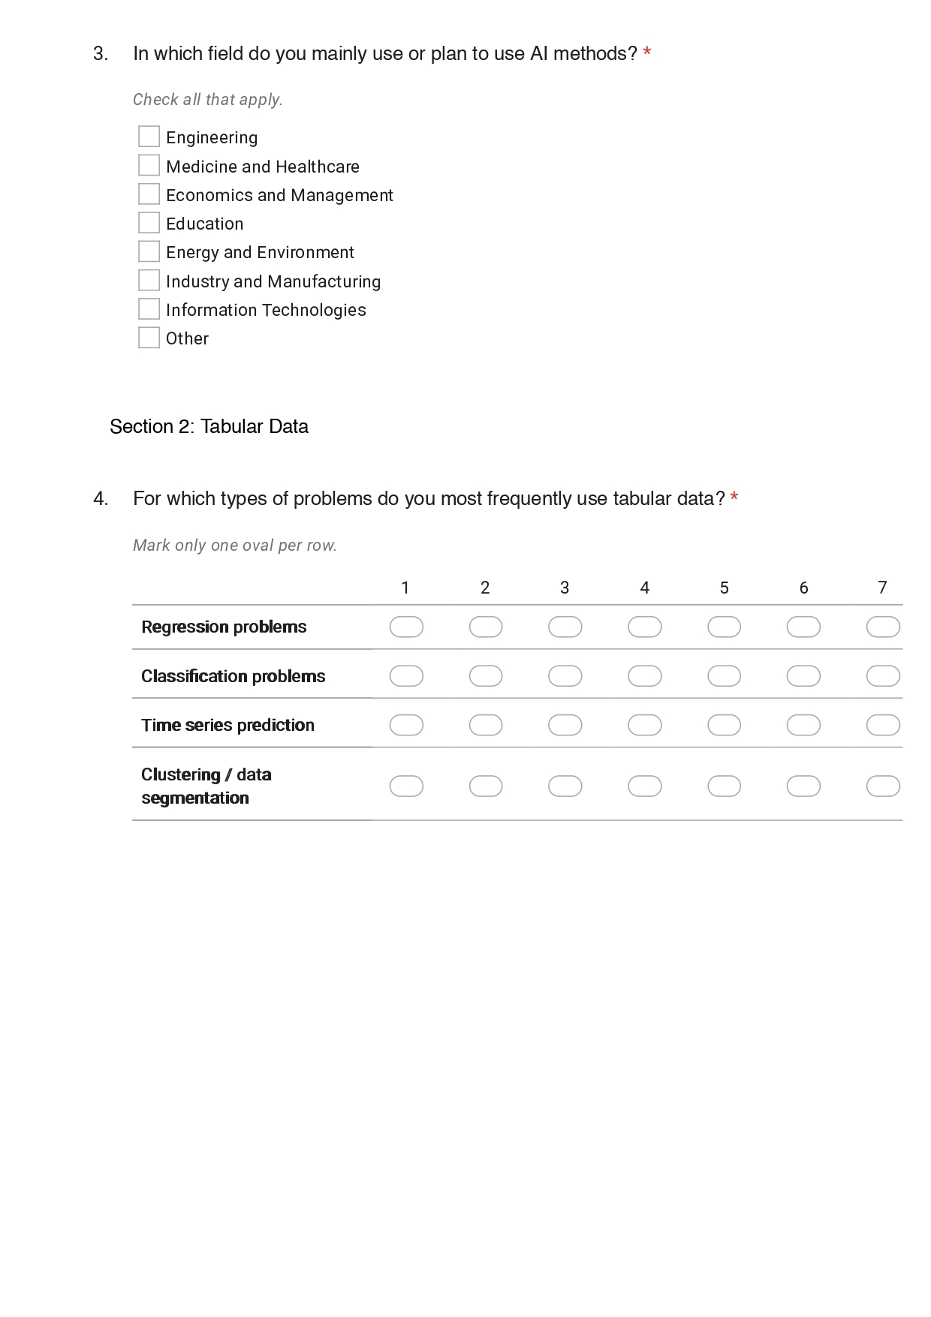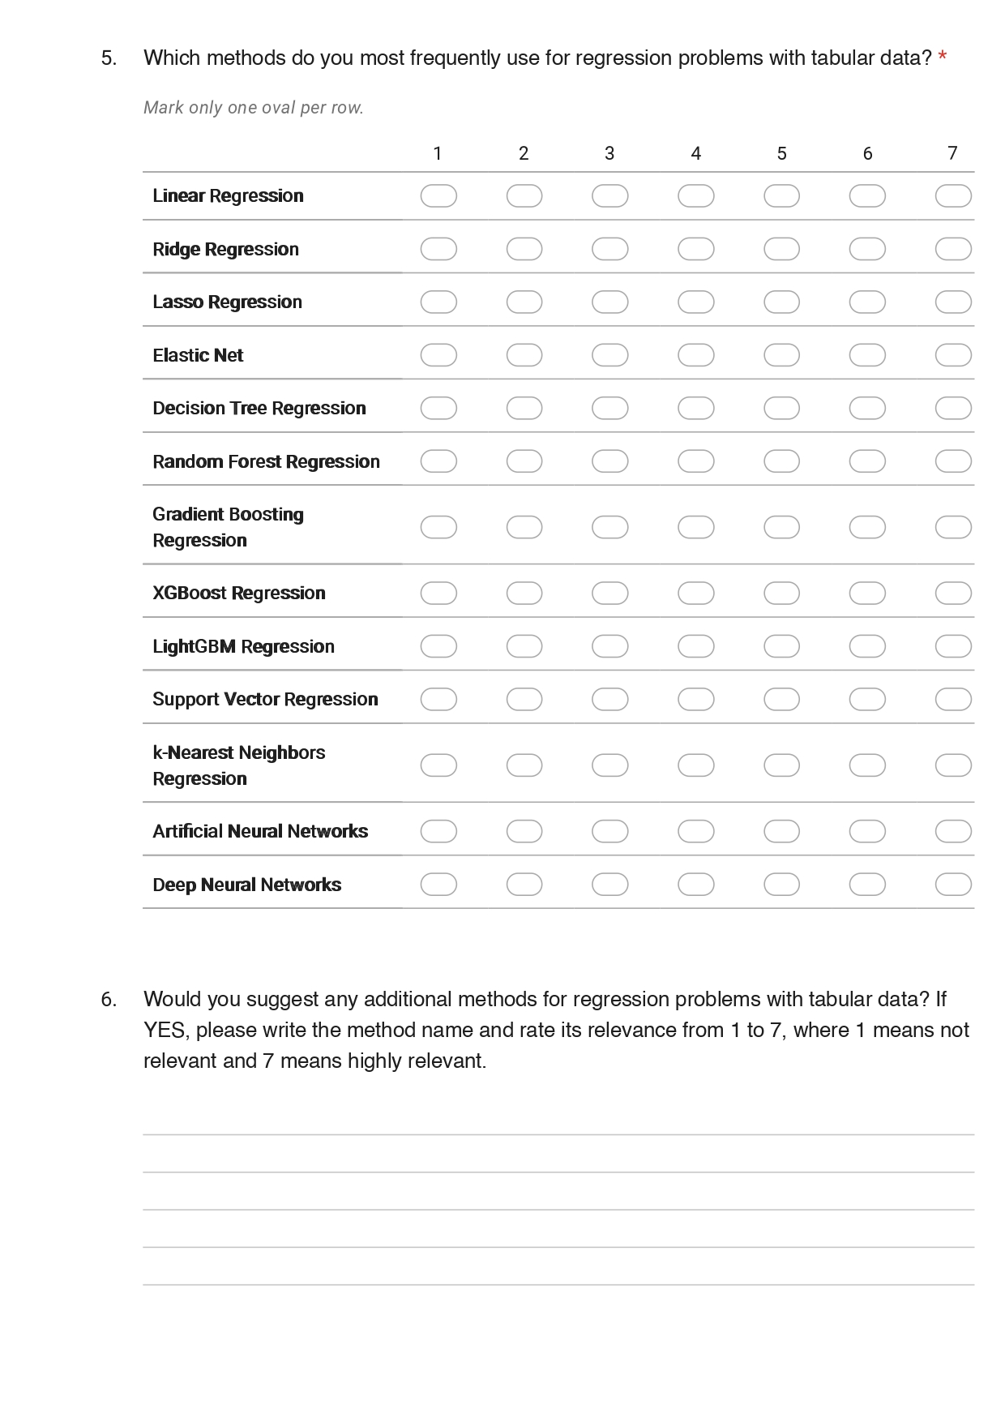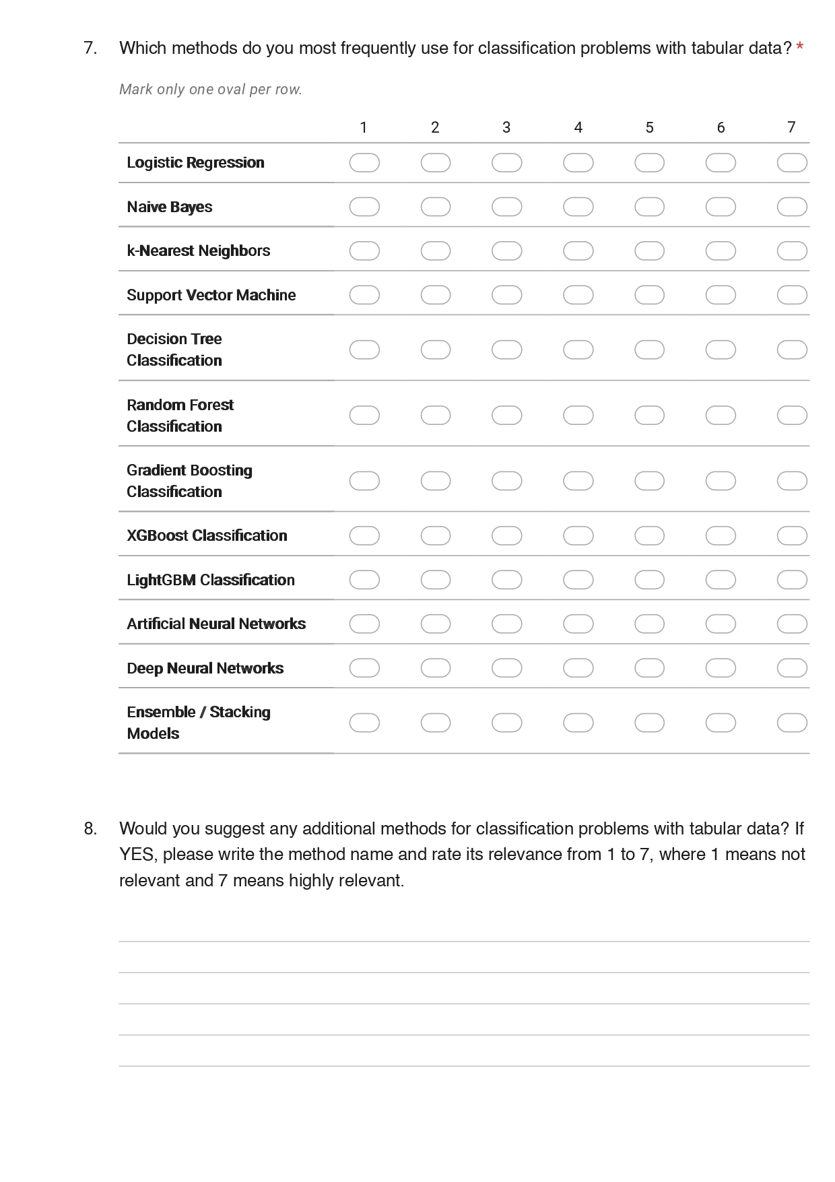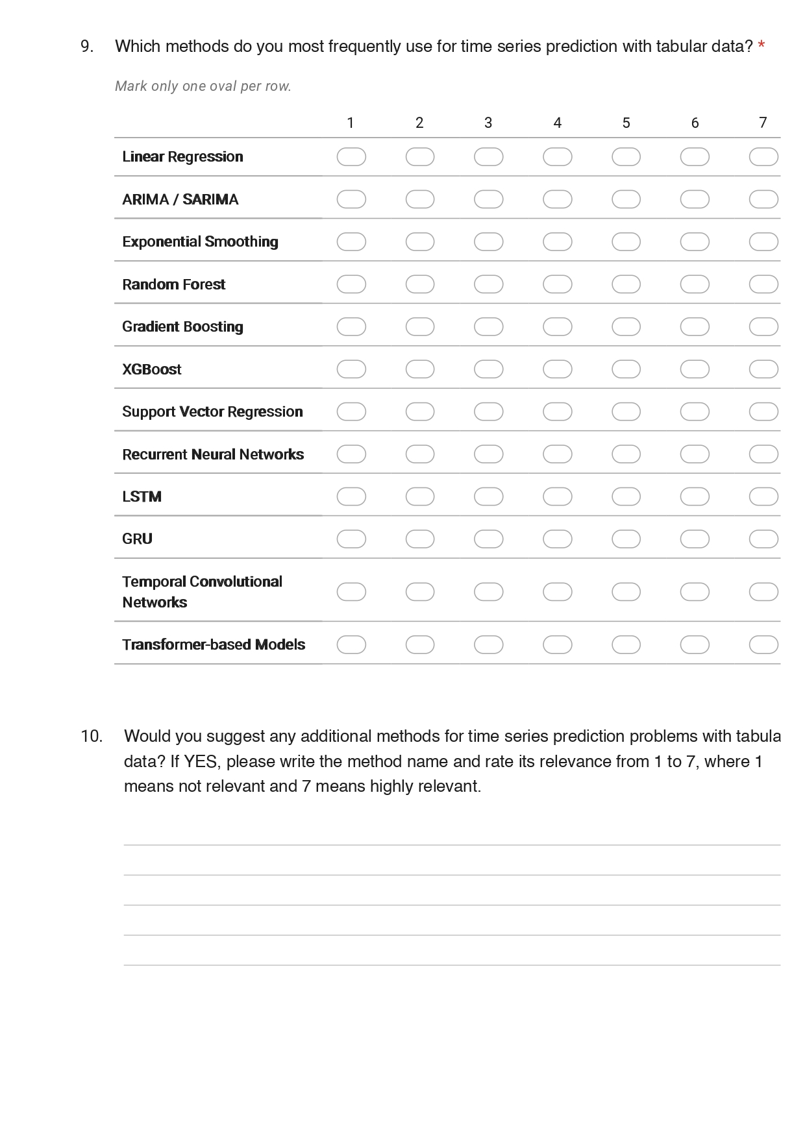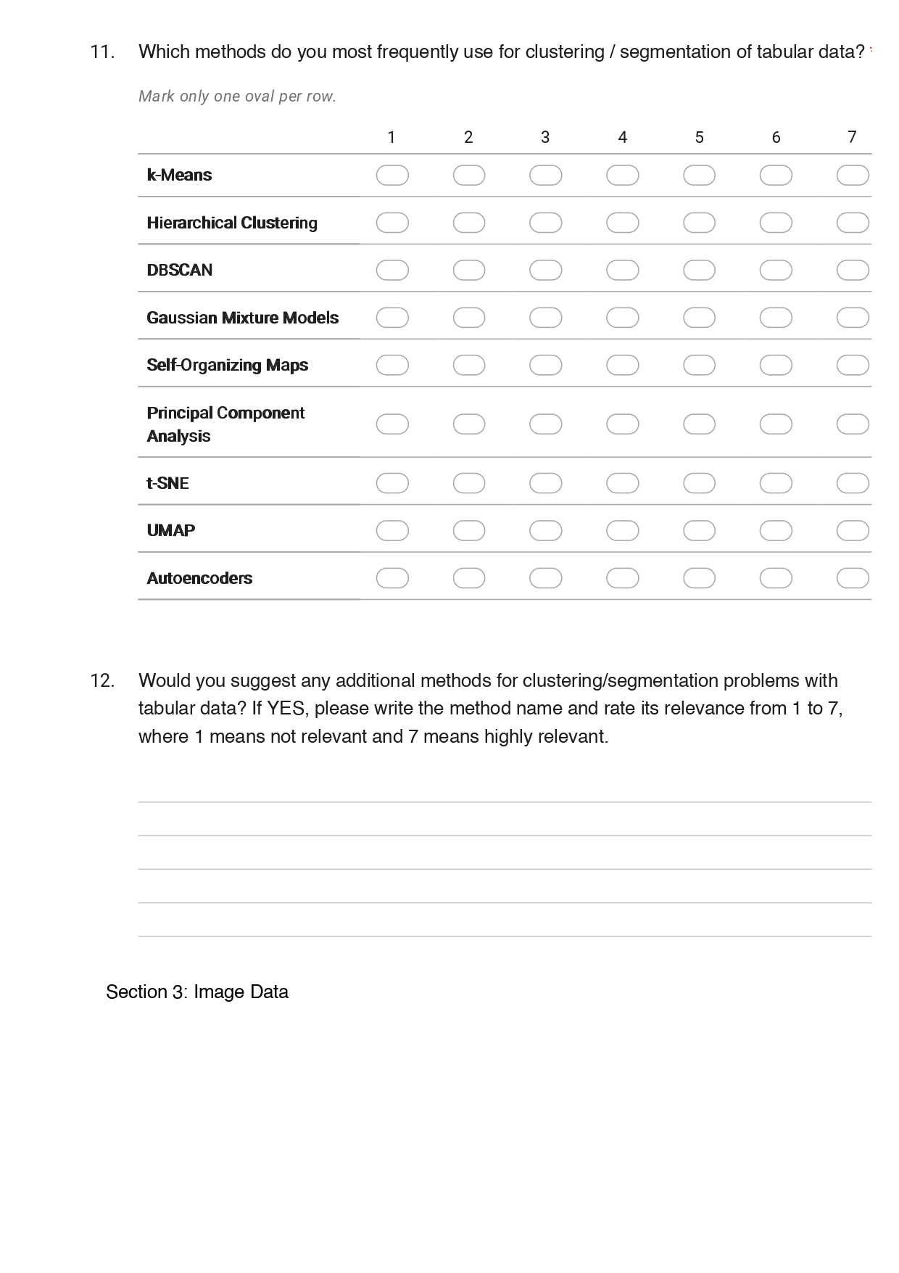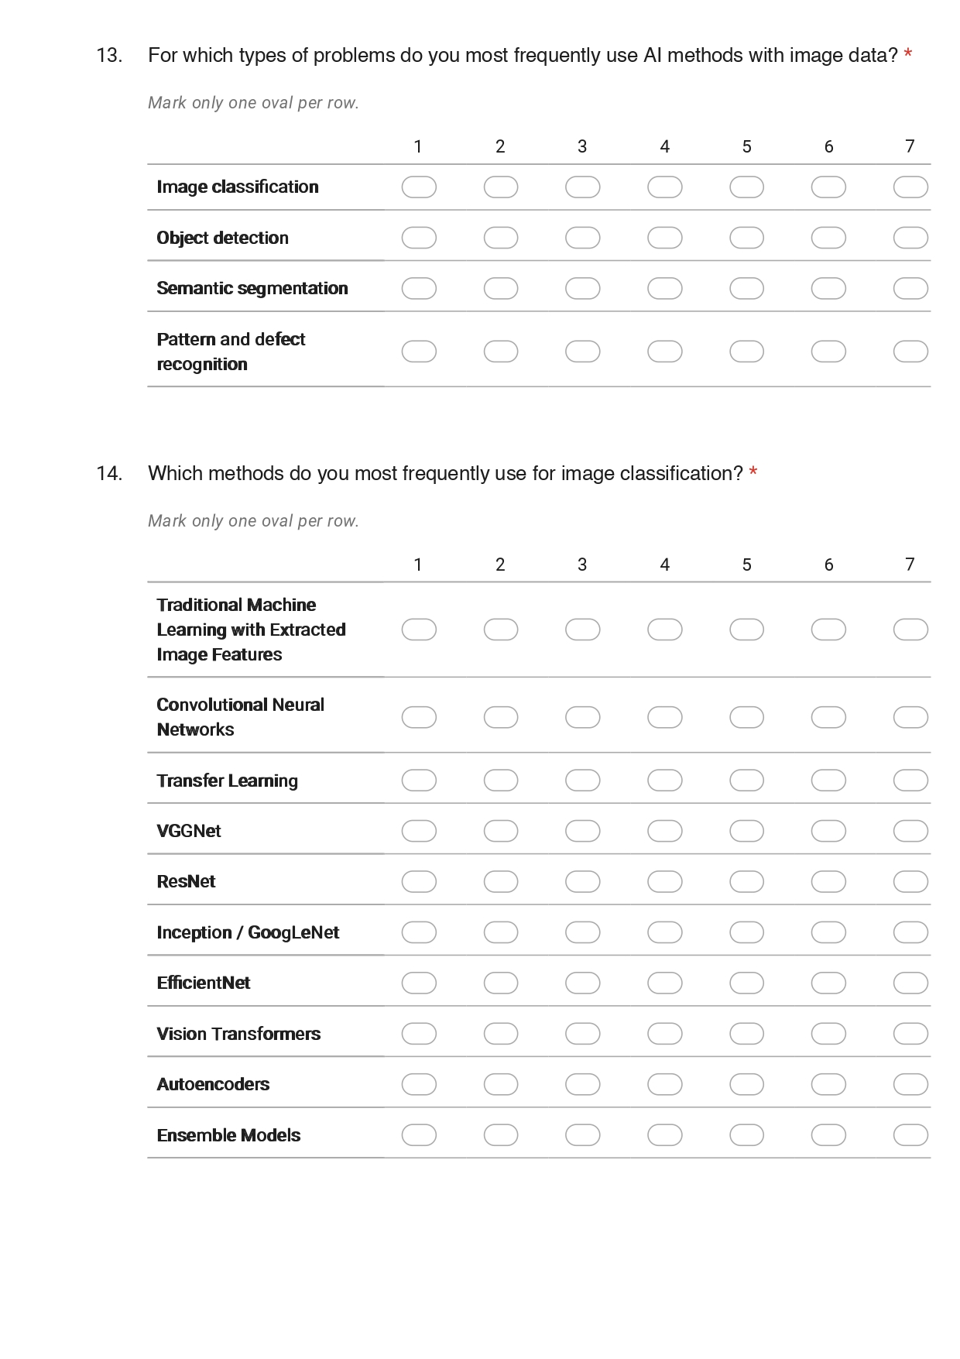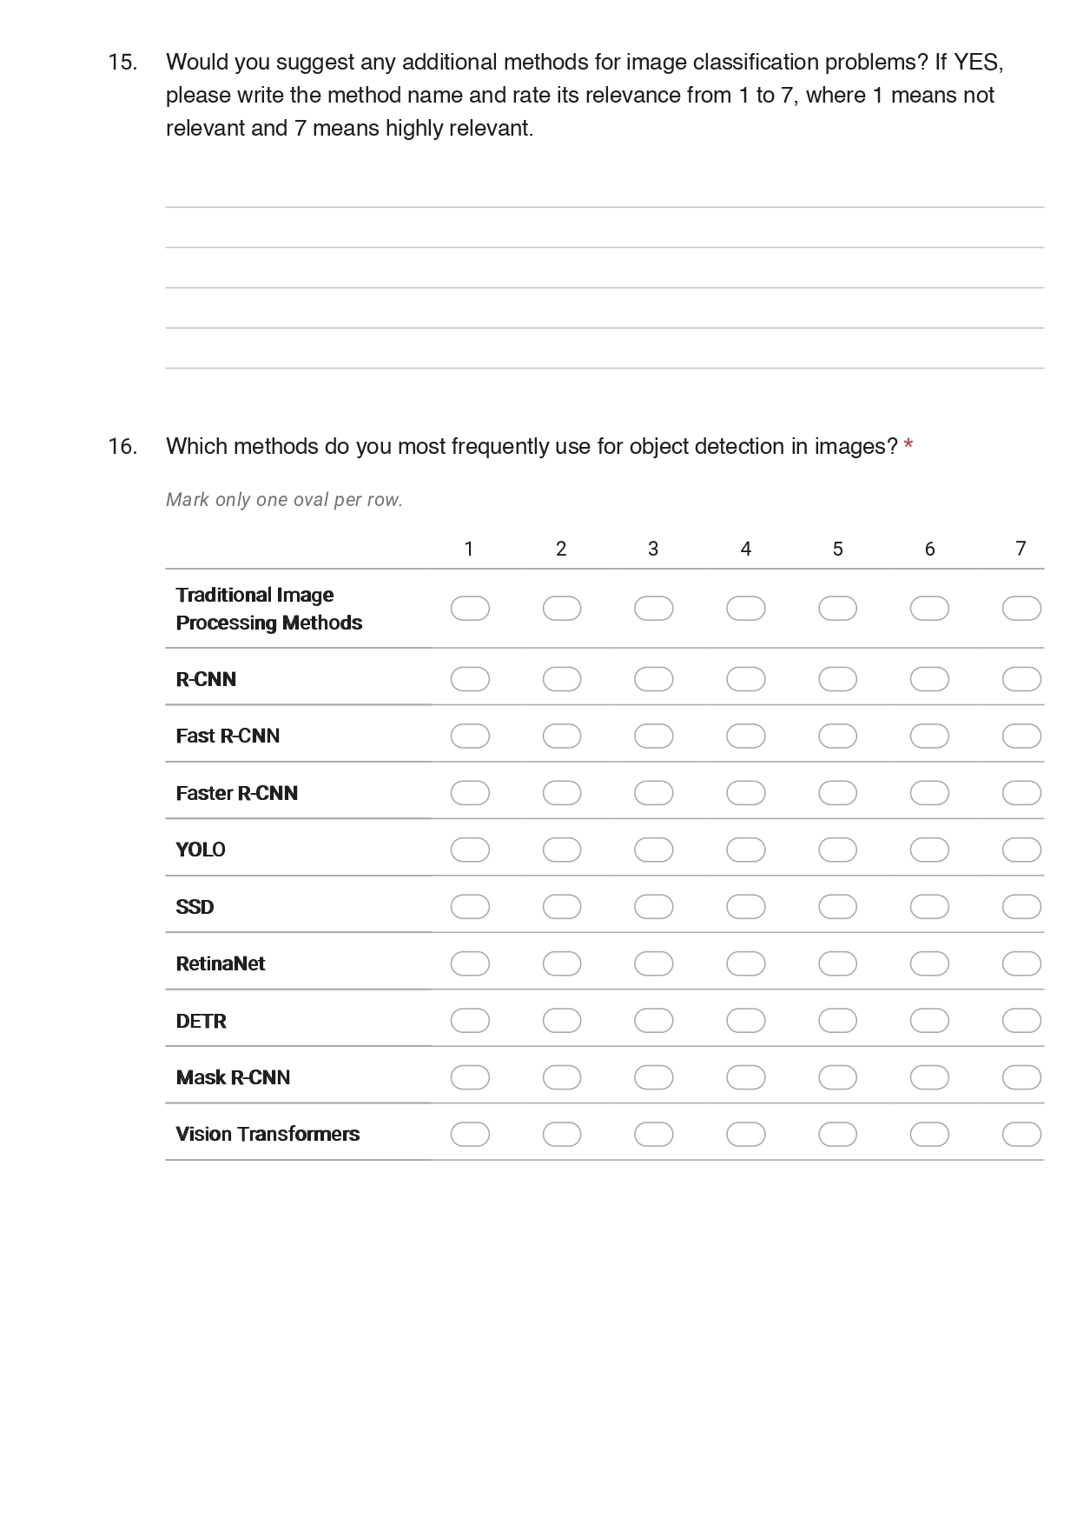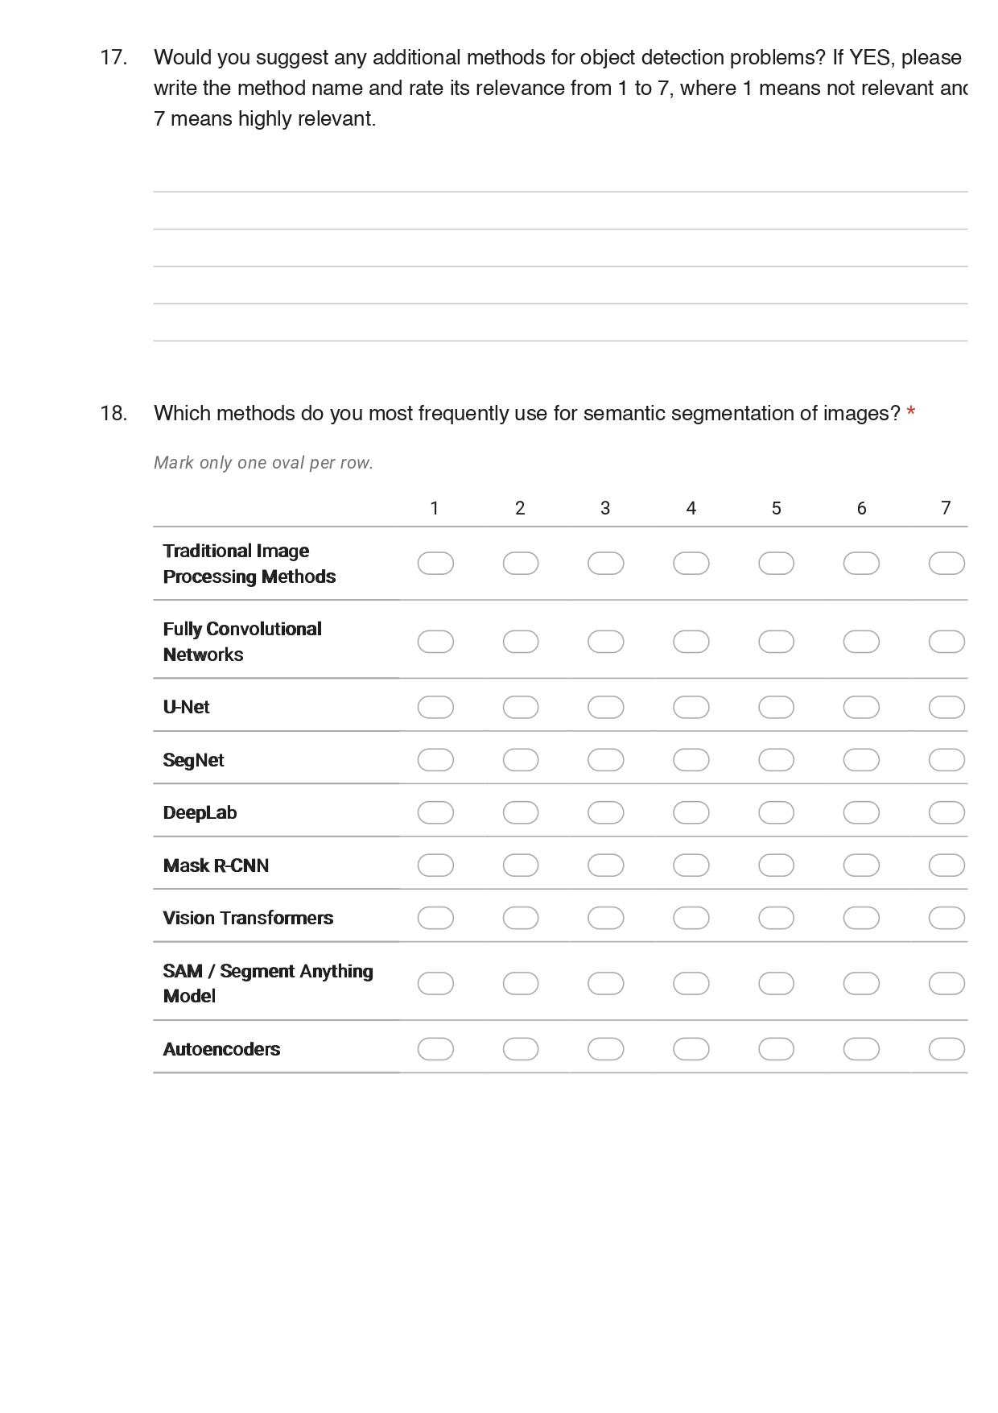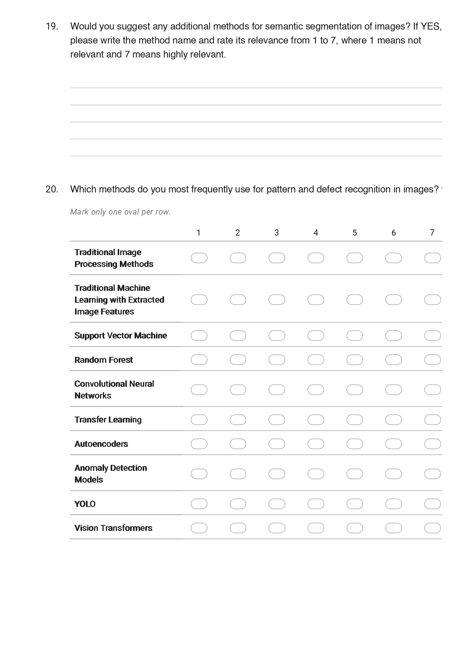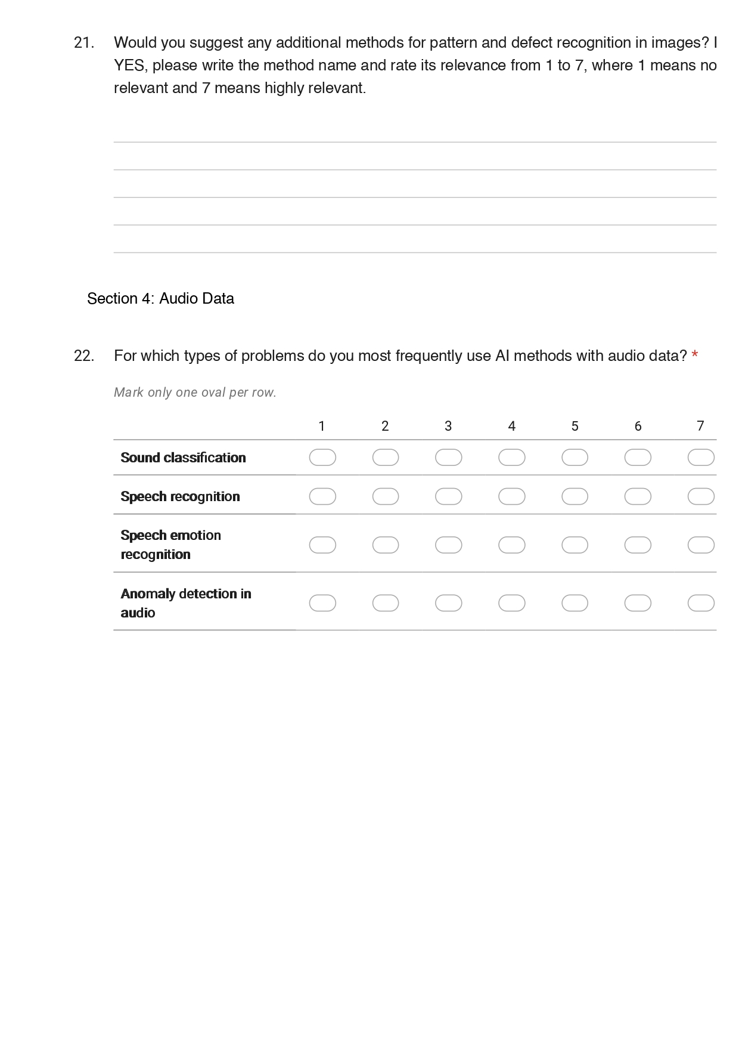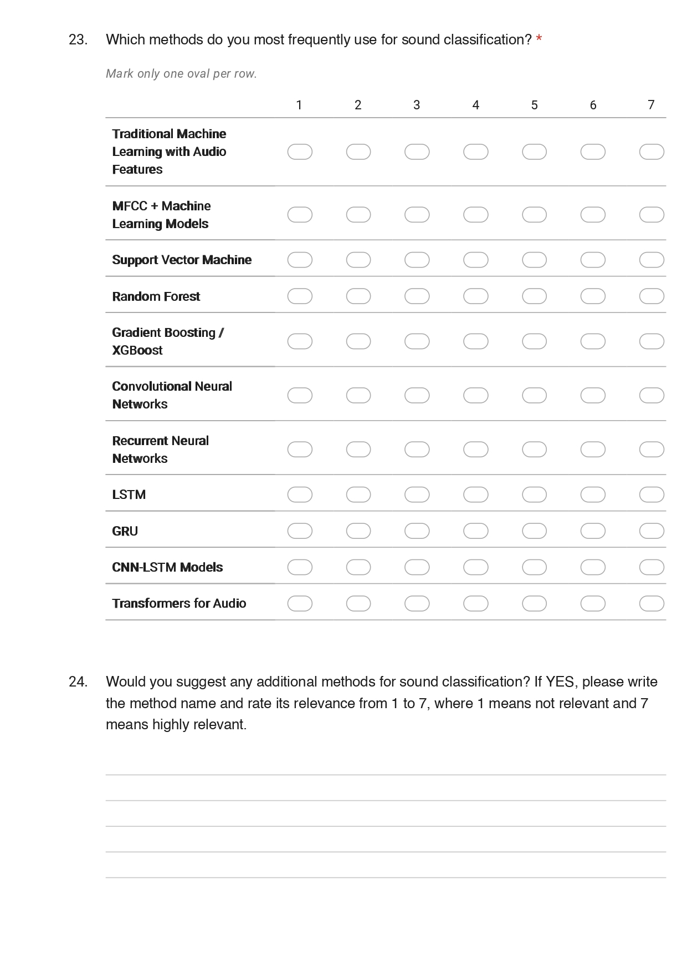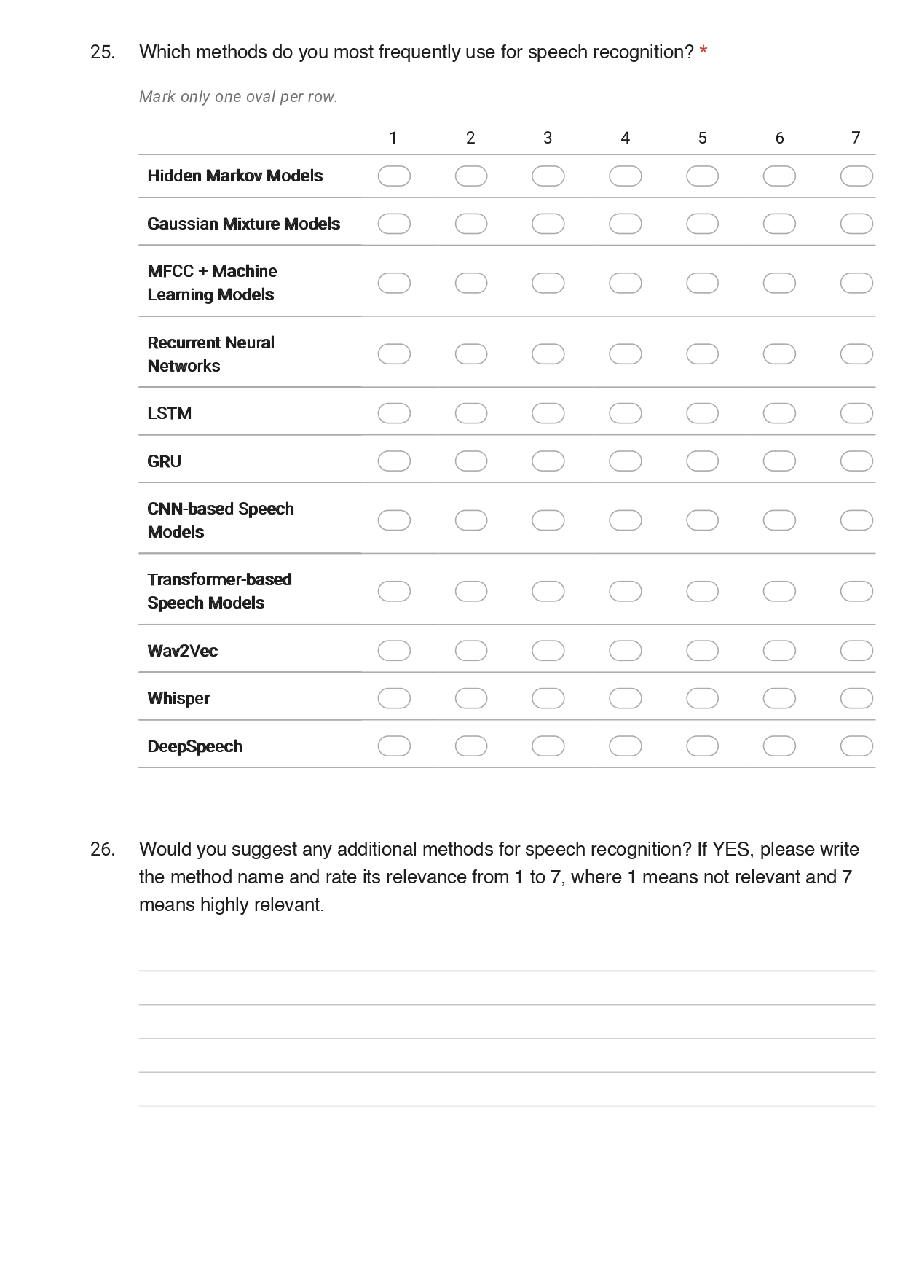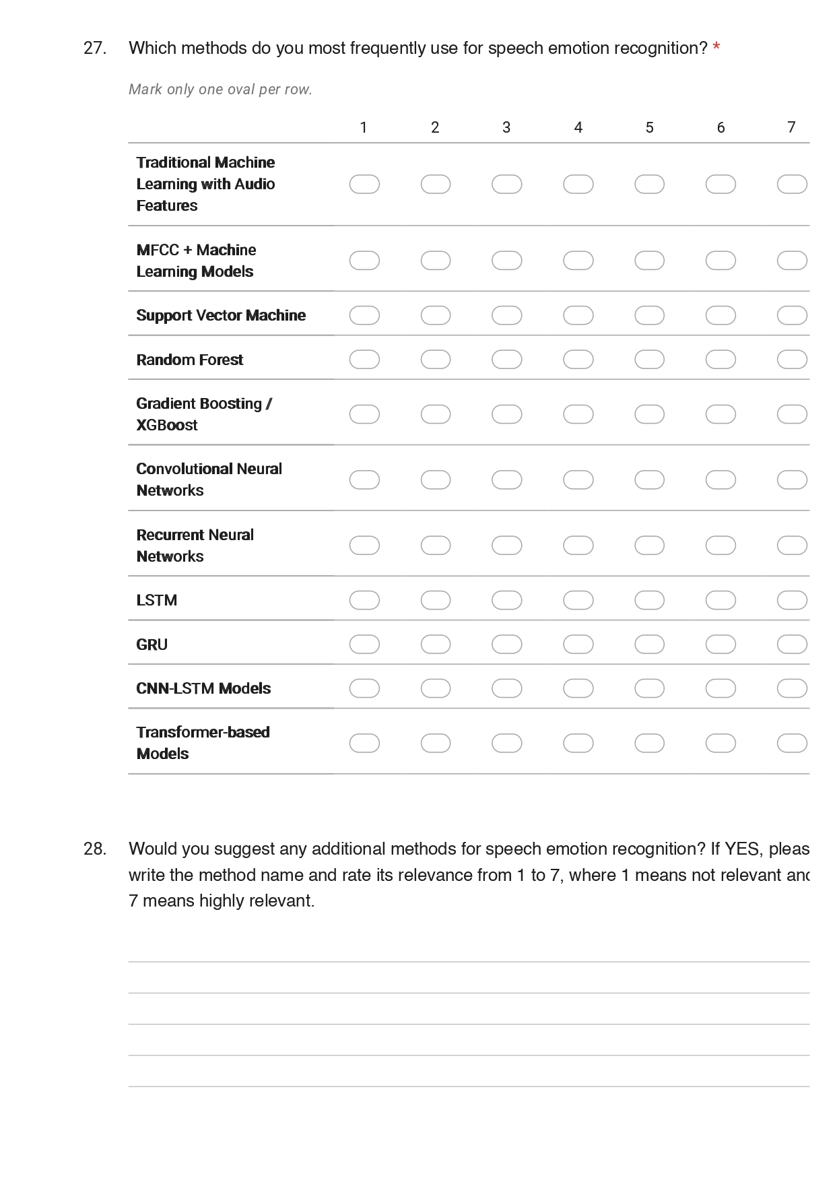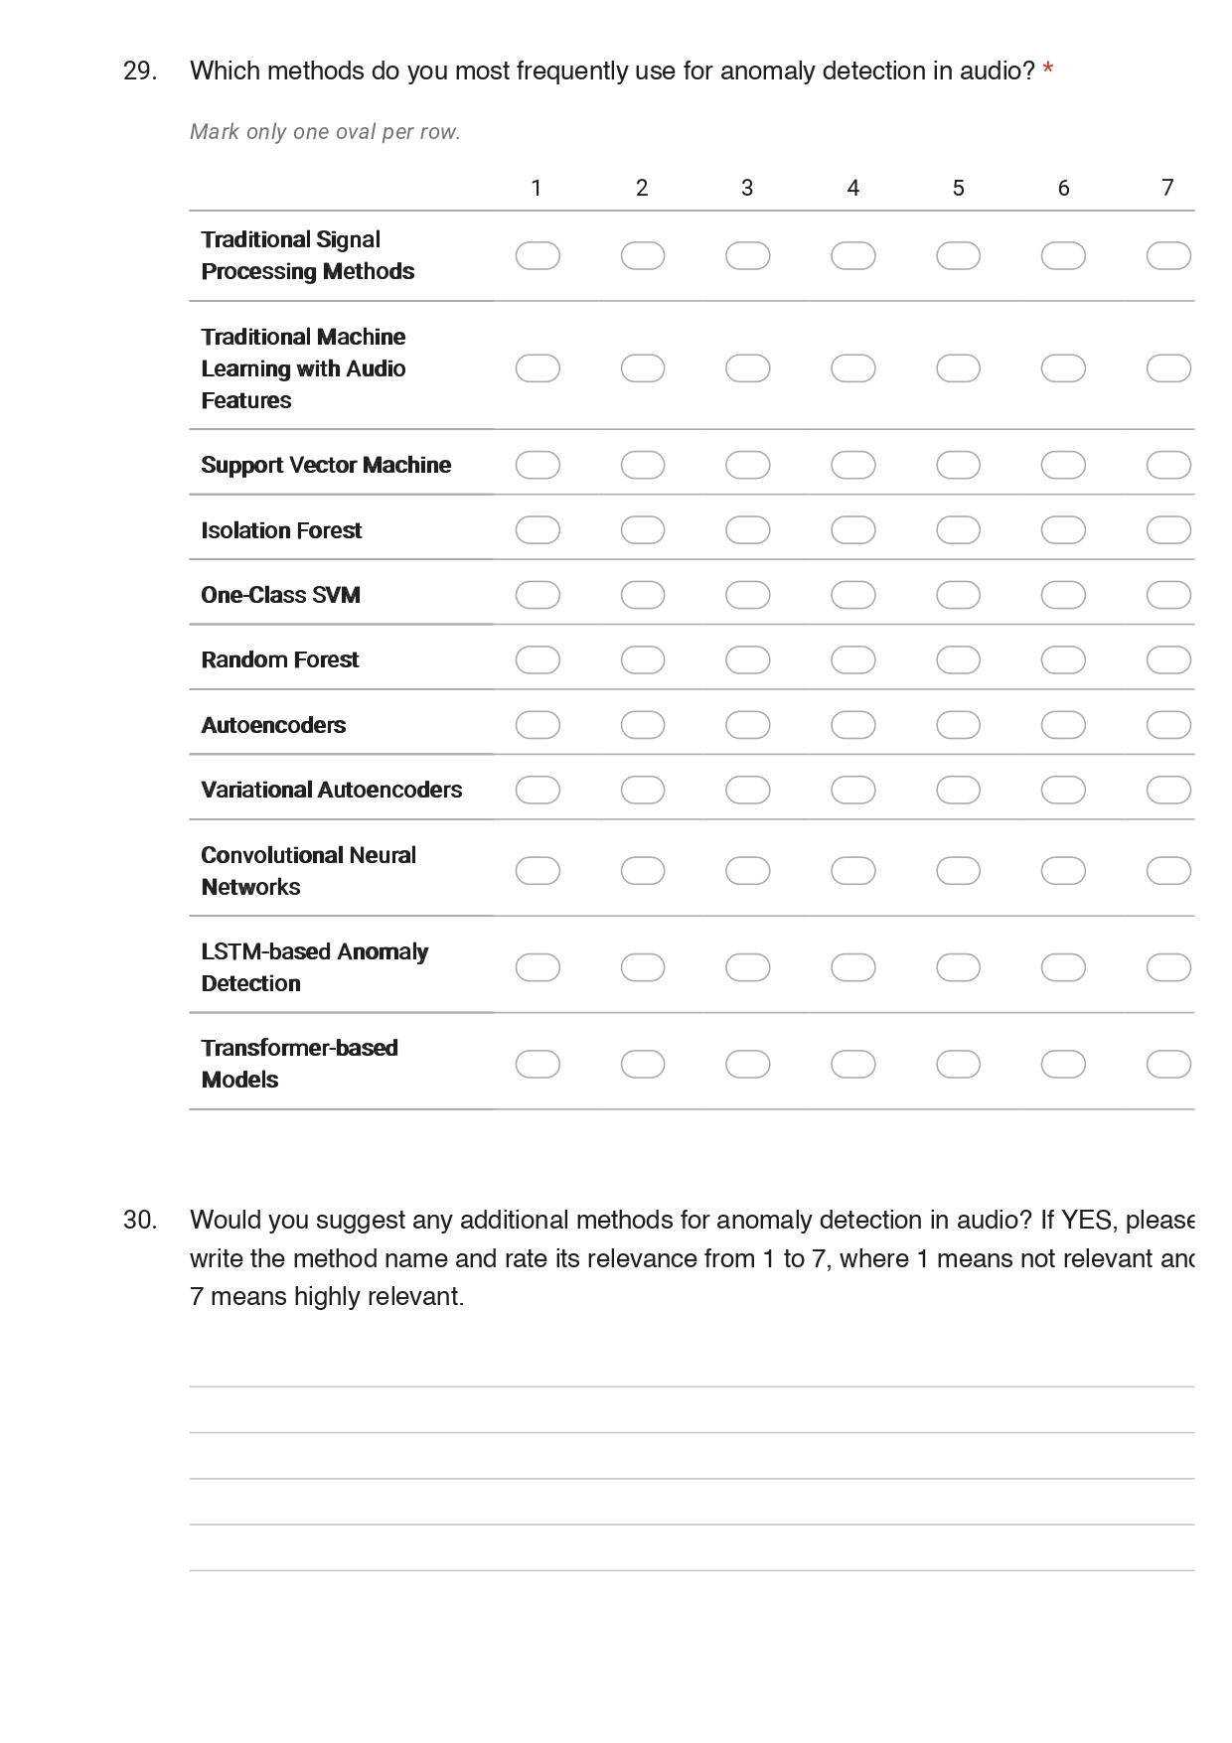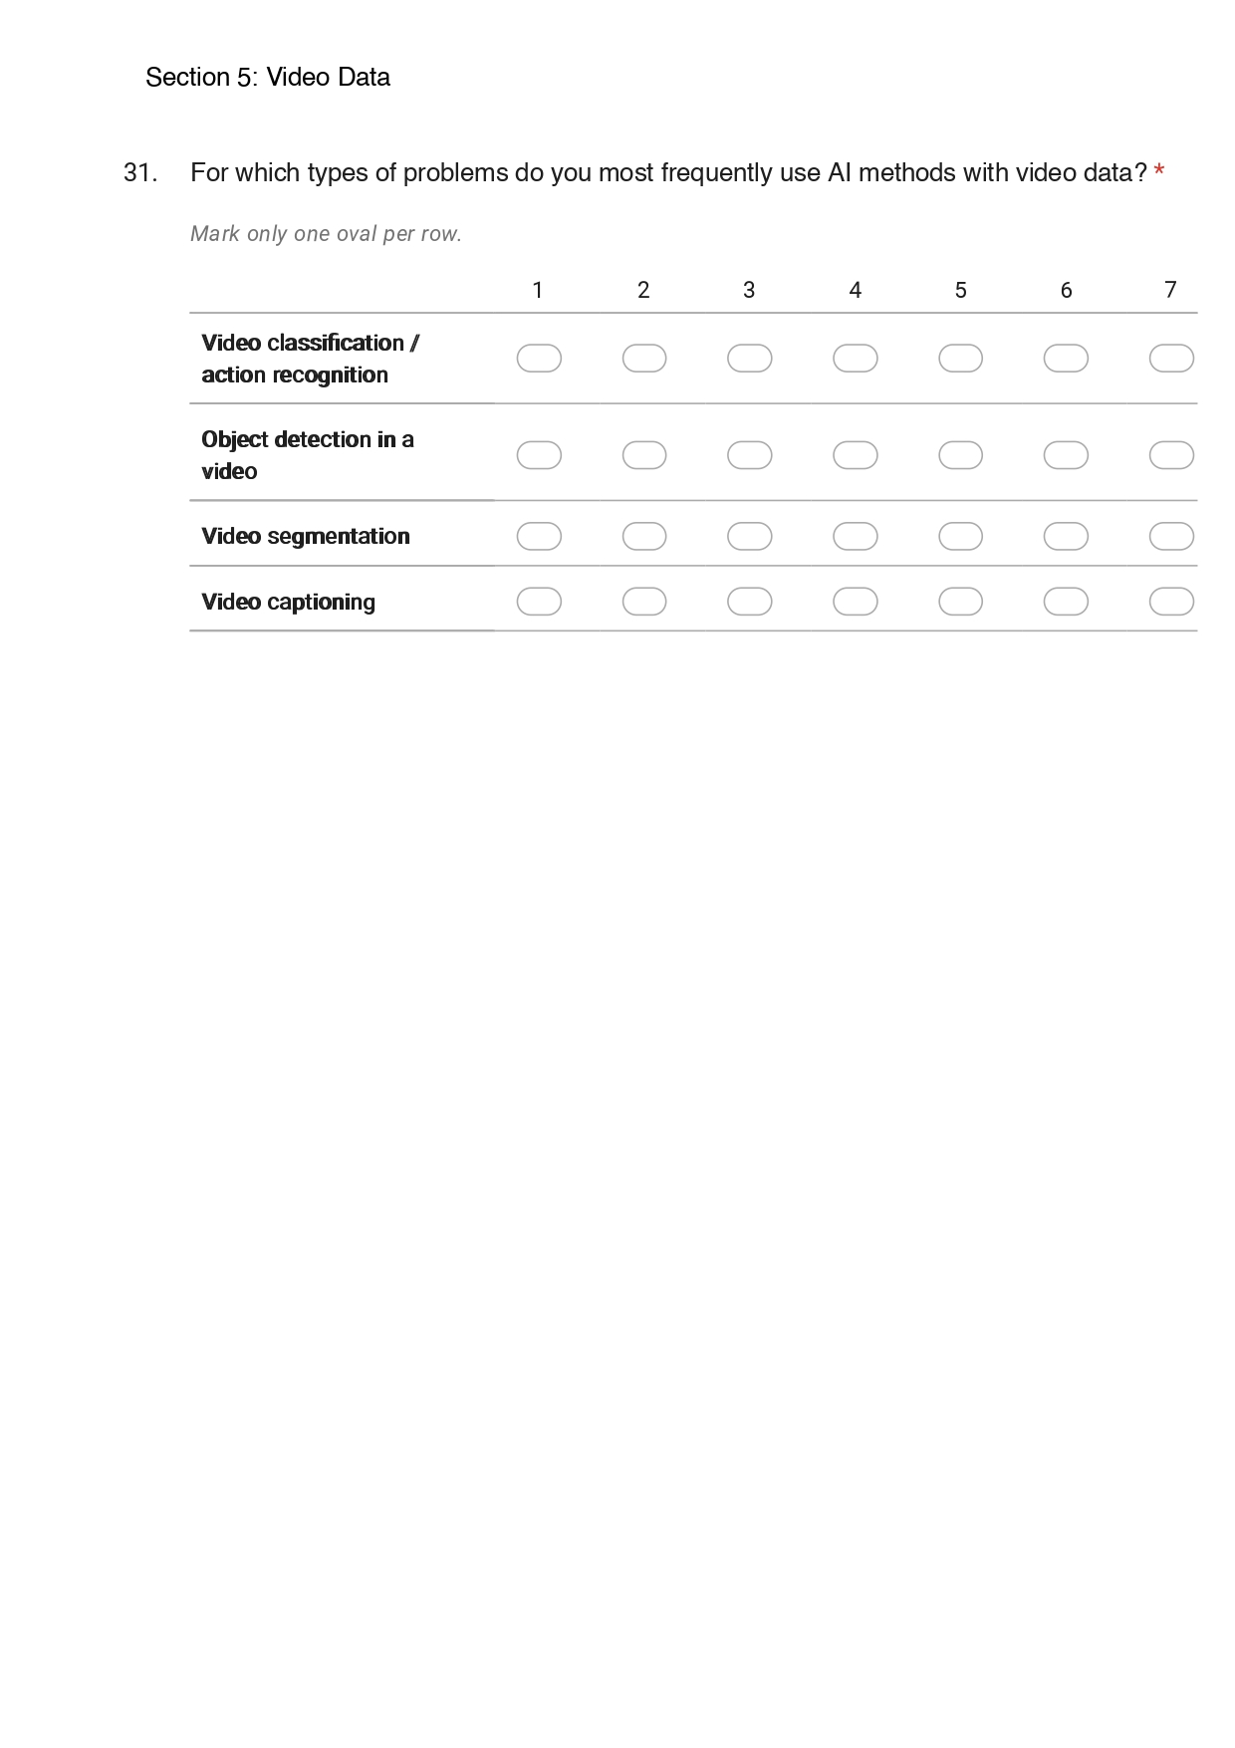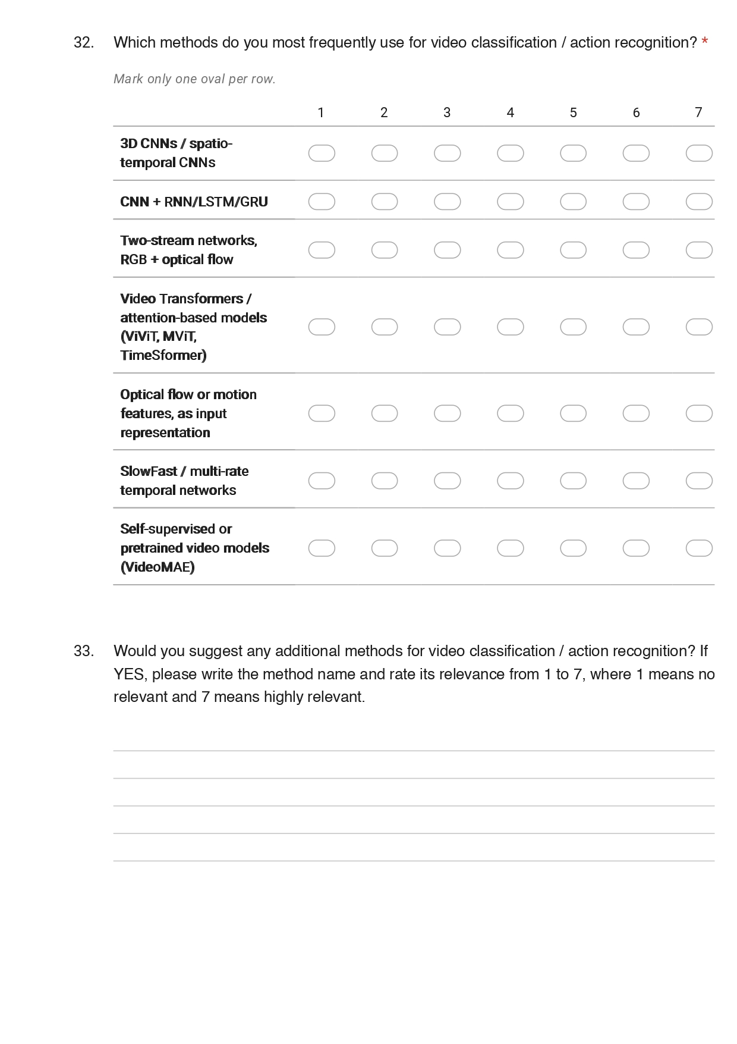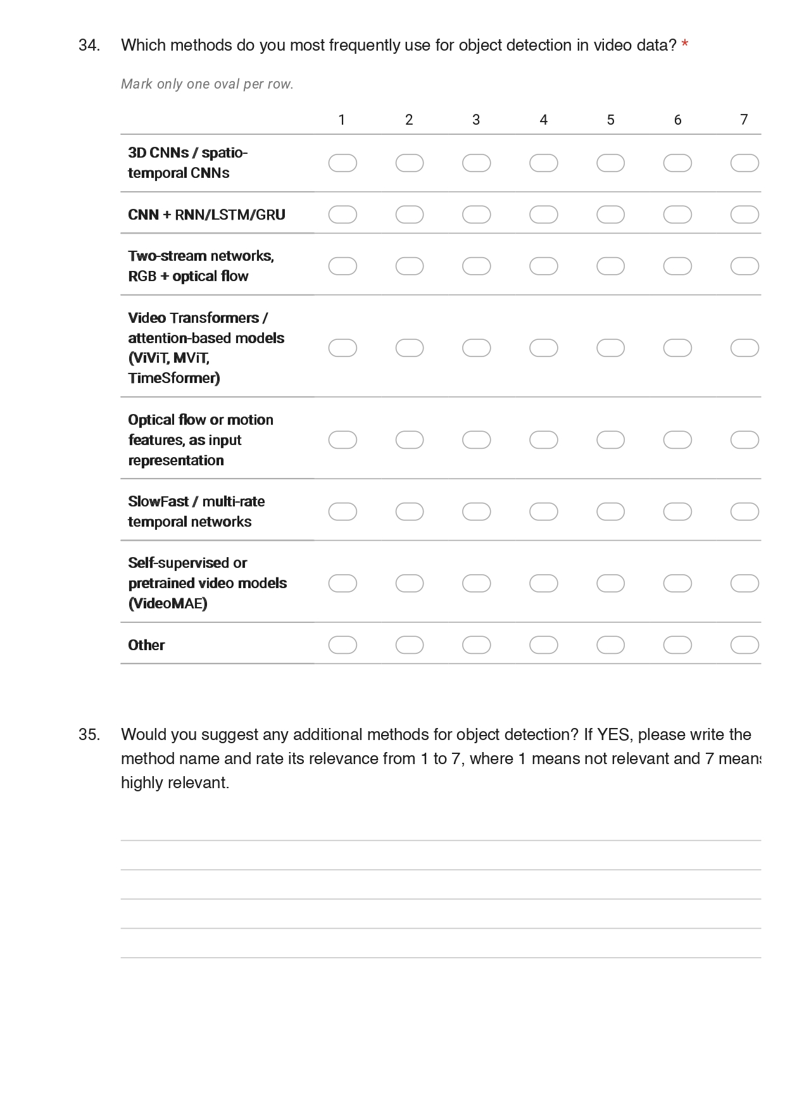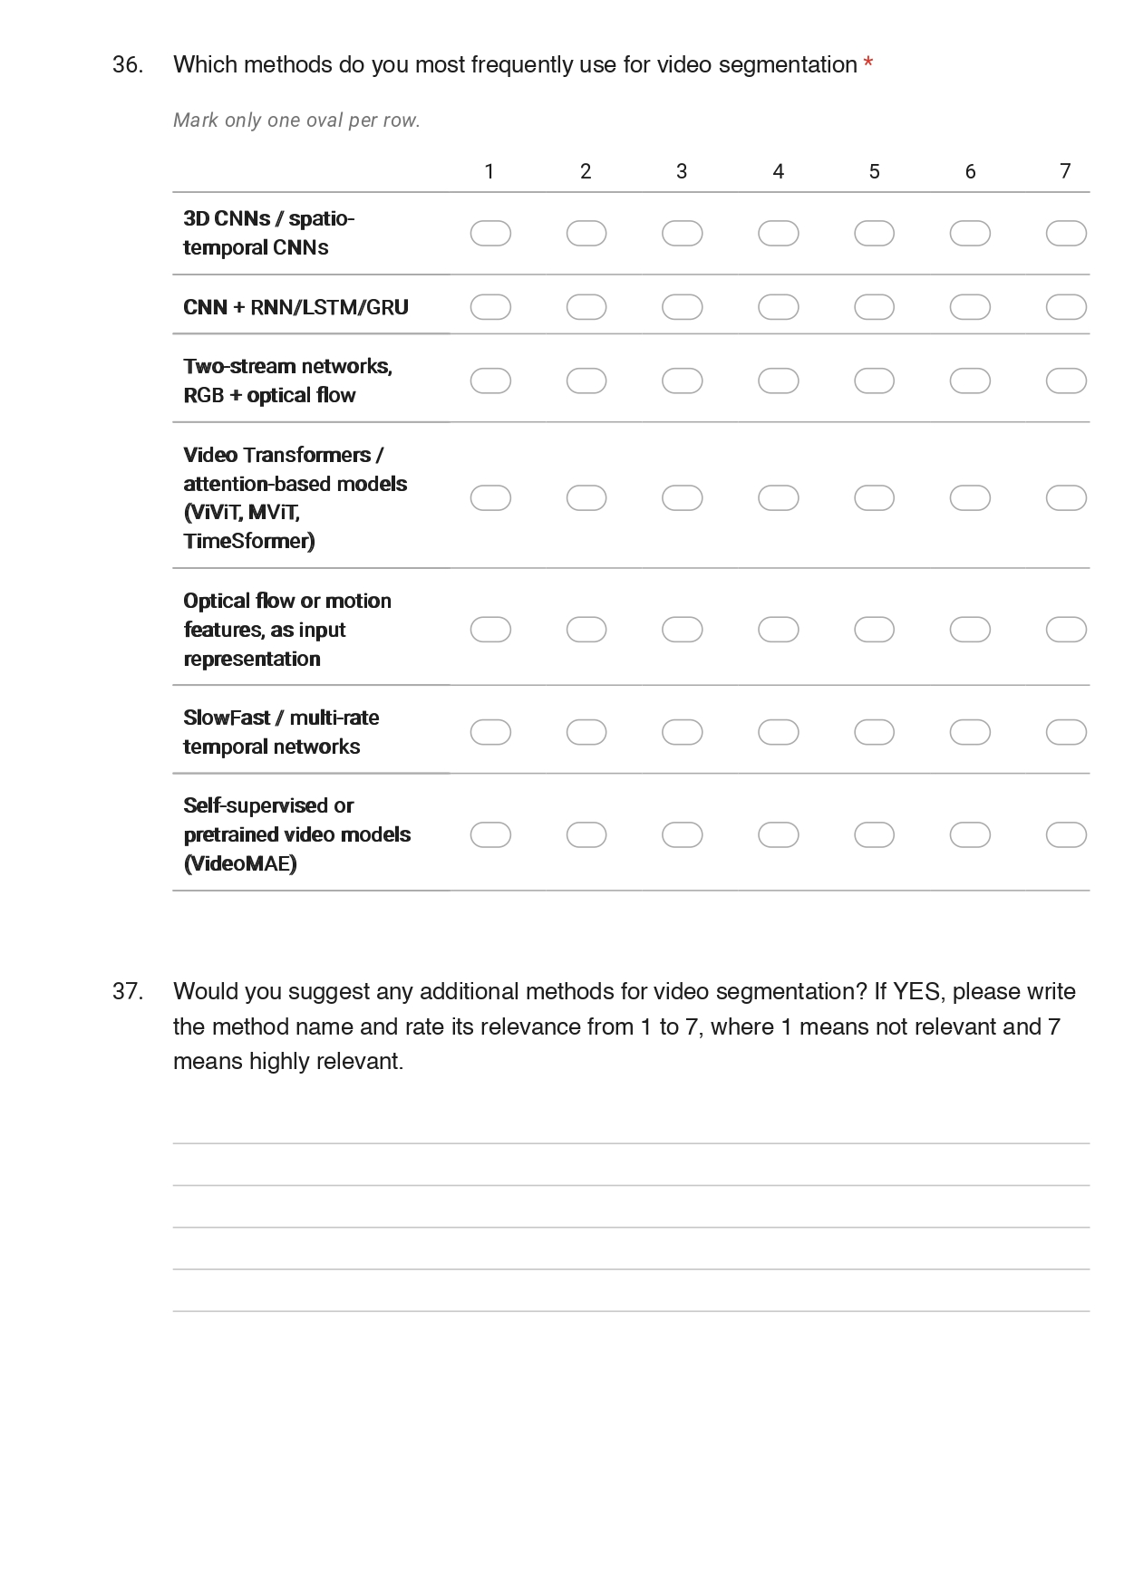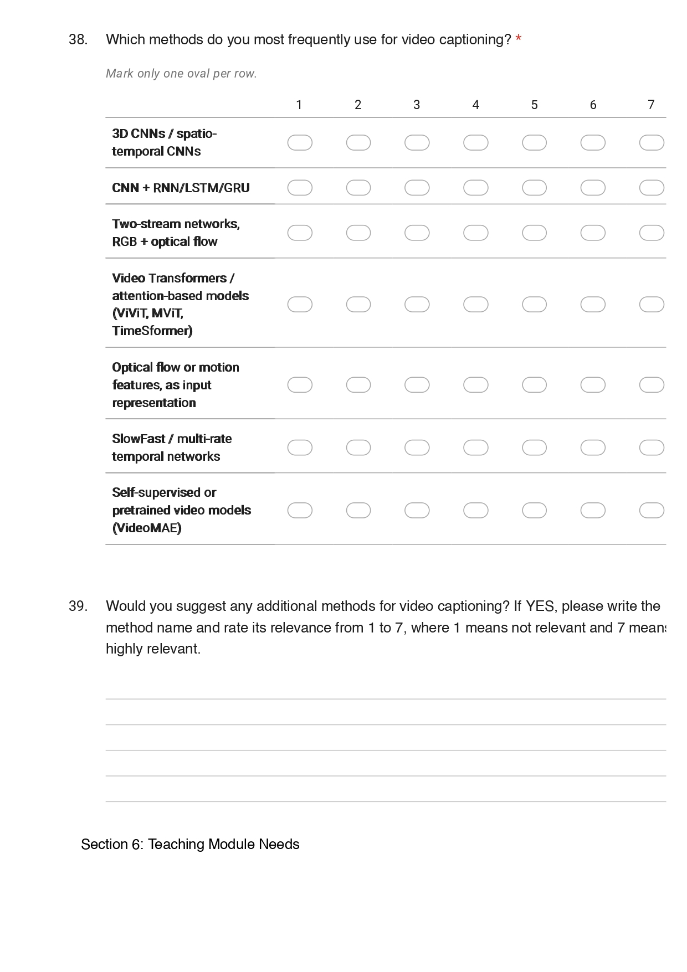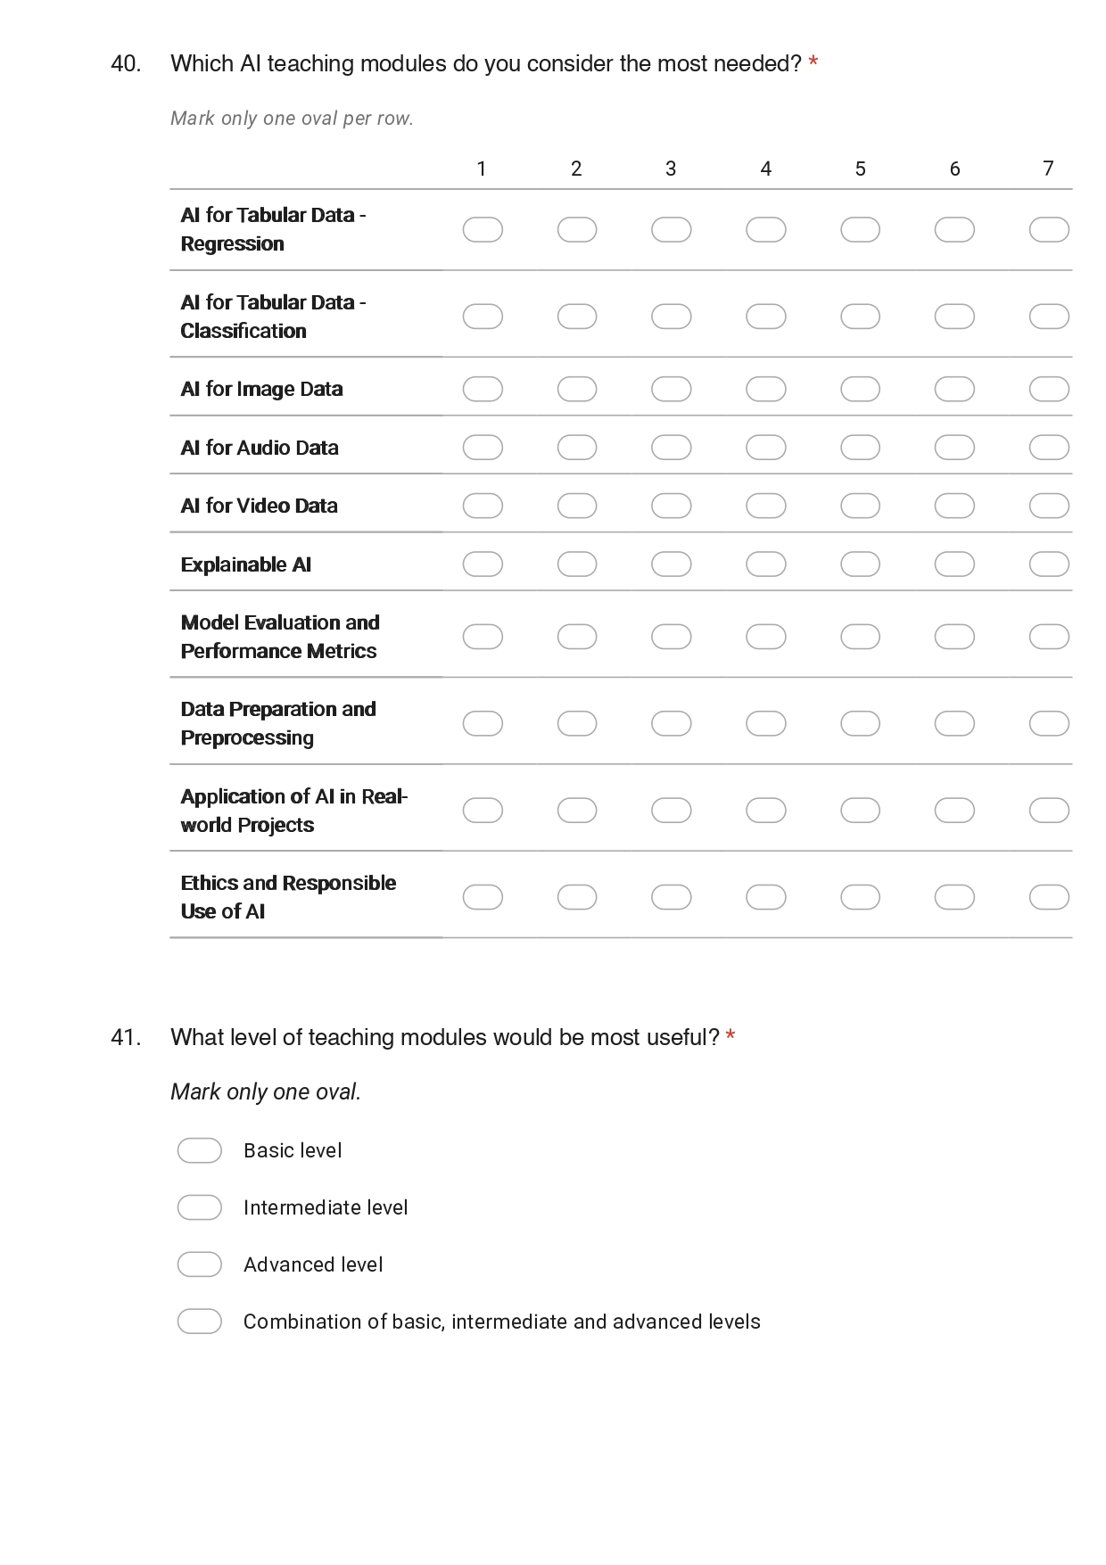 38

1. Introduction and purpose of the analysis
This report summarises the results of the TAI (Teaching Artificial Intelligence) survey, whose purpose was to identify which artificial intelligence problem types, methods and tools are actually used by academic staff in the region, and which teaching modules they consider most necessary. The findings are intended to serve as the empirical basis for defining the content, depth and delivery format of the TAI teaching modules.
The questionnaire was organised around four data modalities: tabular data, images, audio and video. Within each modality, respondents rated the relevance of typical problem types and then of individual methods on a seven-point scale. The final section addressed the priority of teaching modules, the preferred level of difficulty, the types of teaching material and the software environments in use. The responses are completely anonymous.

2. Sample and respondent profile
All 30 questionnaires were fully completed and there are no missing values. Respondents come from five project partner institutions and are almost evenly divided between senior and junior staff, so the results reflect both the perspective of those who design curricula and that of those who deliver hands-on teaching.
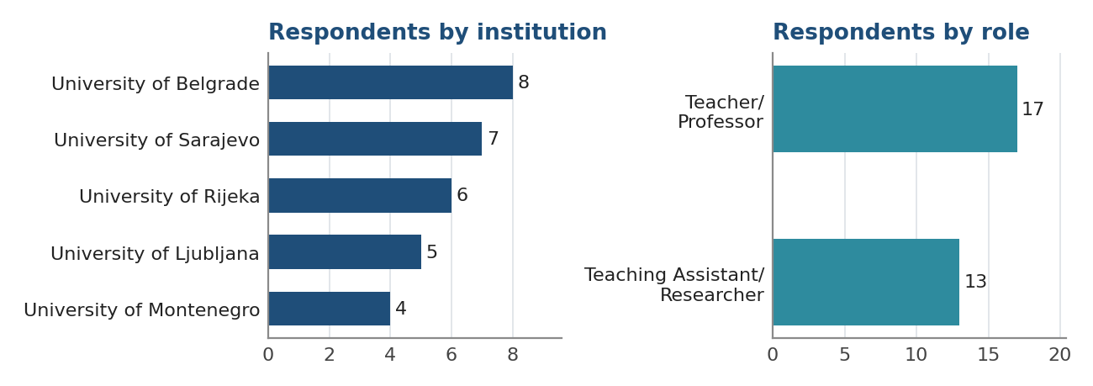
Figure 1. Distribution of respondents by institution and by role
Engineering is the dominant field of application (29 of 30 respondents), followed by education (16), information technologies (7), medicine and healthcare (5), economics and management (3), industry and manufacturing (3) and energy and environment (2). Most respondents selected more than one field, which indicates that AI is applied in an interdisciplinary manner rather than within a single narrow domain.

3. Relevance of problem types across data modalities
A comparison across the four modalities shows a hierarchy of interest. Image data (overall mean 5.30) and tabular data (5.19) are far ahead of video (3.81) and audio (3.50). Within these modalities, the highest-rated individual problem types are image classification (6.07), classification on tabular data (5.90), object detection in images (5.87) and regression on tabular data (5.70).
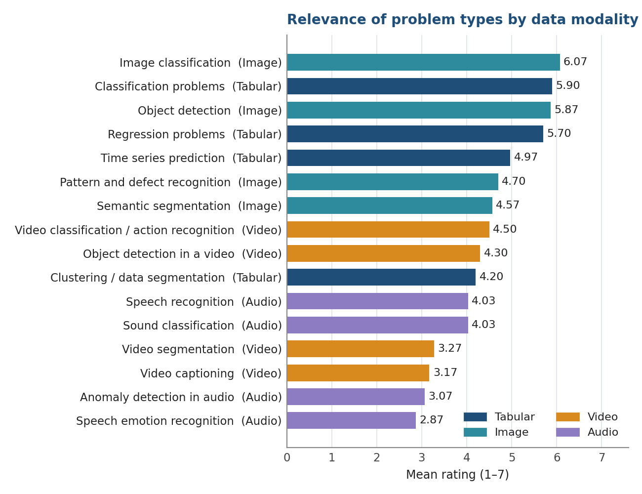
Figure 2. Mean relevance of individual problem types, grouped by data modality
At the other end of the scale are speech emotion recognition (2.87), anomaly detection in audio (3.07), video captioning (3.17) and video segmentation (3.27). Time series prediction (4.97) and clustering (4.20) occupy the middle ground: relevant, but noticeably less central than supervised classification and regression.

4. Tabular data

4.1 Regression
The pattern of responses for regression is characteristic: the highest ratings go to the simplest method and to the most complex ones simultaneously. Linear regression (5.93) leads, immediately followed by artificial neural networks (5.83) and deep neural networks (5.70), and then by XGBoost (5.40) and random forests (5.23). Regularised linear models — ridge (3.73), lasso (3.70) and especially elastic net (2.93) — are rated markedly lower, as is LightGBM (3.63).
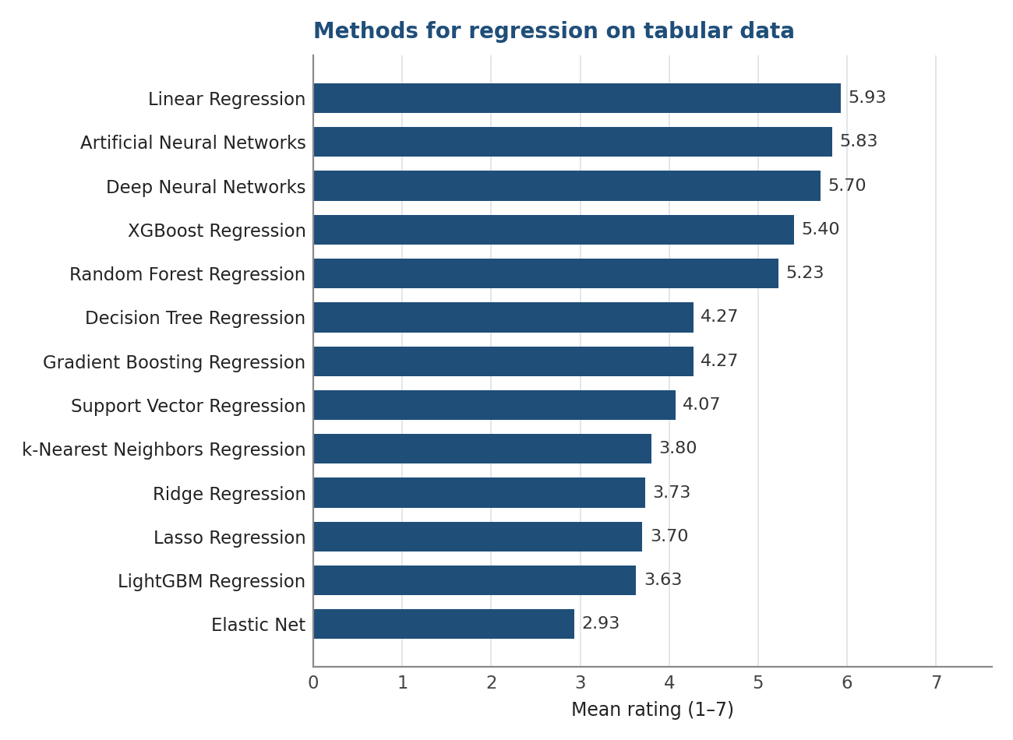
Figure 3. Methods for regression on tabular data (mean rating, n = 30)
The gap between linear regression and its regularised variants is one of the more informative findings in the survey. This suggests that regularisation is under-represented in current practice.

4.2 Classification
For classification, artificial neural networks are rated highest (6.07), ahead of random forests (5.87), deep neural networks (5.77) and logistic regression (5.57). Ensemble and stacking models (5.20) and XGBoost (5.13) follow. Naive Bayes (3.77) and LightGBM (3.63) are at the bottom of the ranking.
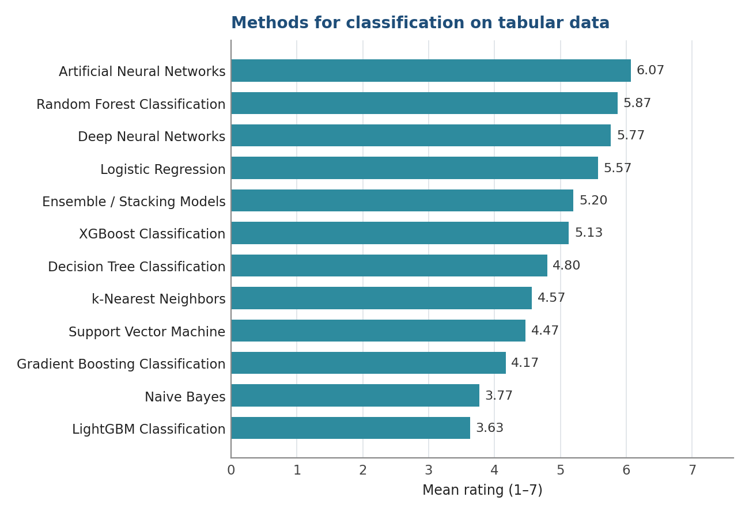
Figure 4. Methods for classification on tabular data

4.3 Time series prediction
Recurrent architectures dominate: LSTM (5.47), recurrent neural networks (5.37) and GRU (5.37), followed by XGBoost (5.17). Classical statistical approaches are rated lower. ARIMA/SARIMA reaches 4.73 and exponential smoothing only 3.93, while transformer-based models (4.57) and temporal convolutional networks (4.27) indicate an interest in newer approaches that has not yet translated into everyday practice.
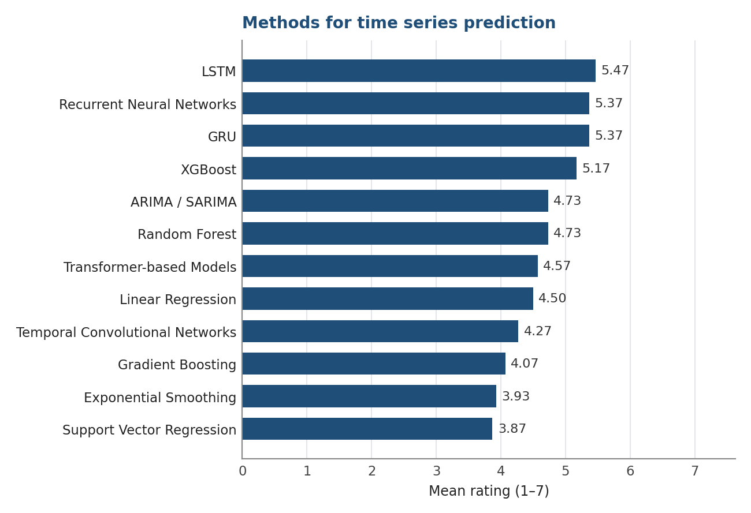
Figure 5. Methods for time series prediction

4.4 Clustering and segmentation
This is the least developed area within tabular data. Only k-means (5.53) and hierarchical clustering (5.07) exceed a rating of 5, and autoencoders reach 4.80. Density-based and modern dimensionality-reduction techniques are rated low such as DBSCAN 3.93, t-SNE 3.77, Gaussian mixture models 3.70, self-organising maps 3.50 and UMAP 3.37. Principal component analysis, at 4.20, is also below what would be expected for a technique of such general applicability.
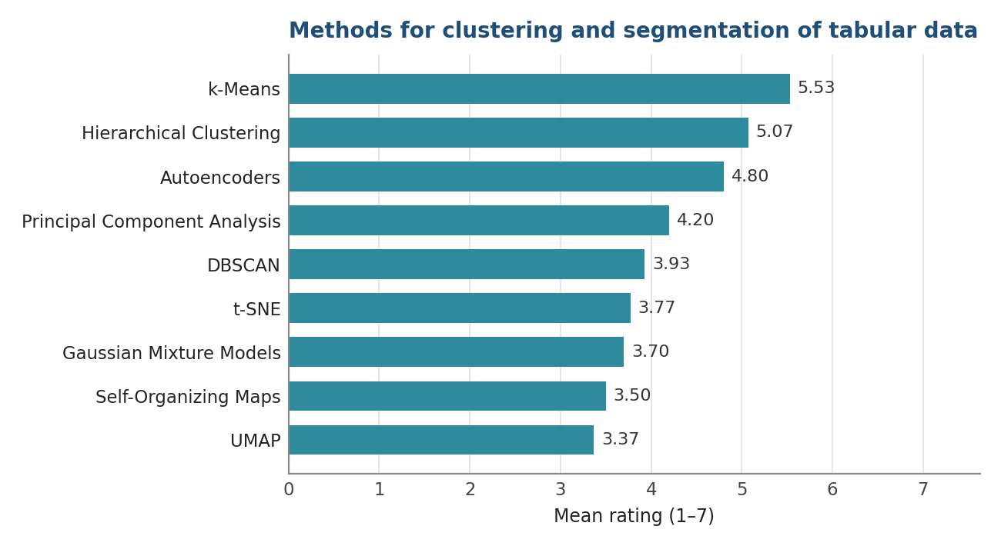
Figure 6. Methods for clustering and segmentation of tabular data

5. Image data
Image data is the strongest modality overall. Convolutional neural networks receive the single highest rating in the entire survey (6.40), with 83 % of respondents rating them 6 or 7. Transfer learning follows at 5.50, and among specific architectures ResNet (5.00) is ahead of VGGNet (4.67), Inception (4.53) and EfficientNet (4.53).
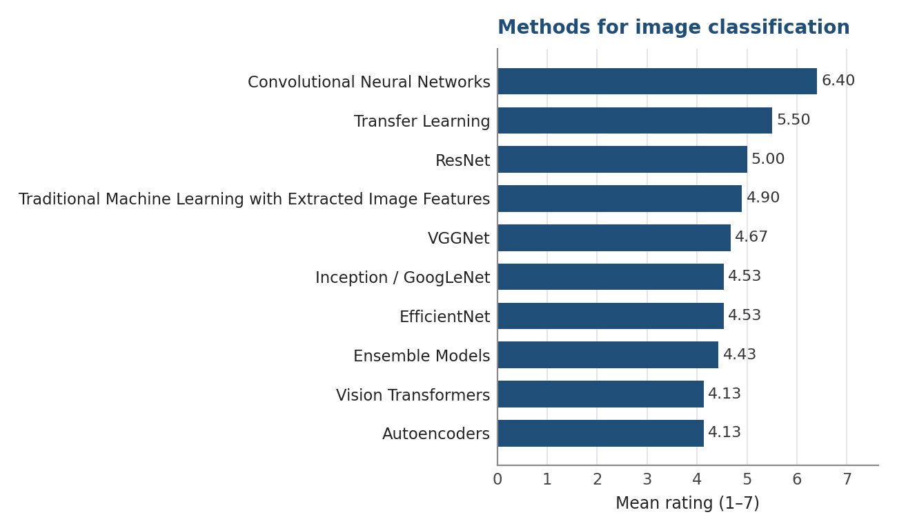
Figure 7. Methods for image classification
In object detection the picture is unusually one-sided: YOLO stands at 5.93, while the entire R-CNN models remain below 4.2 (Fast R-CNN 4.13, Faster R-CNN 3.97, R-CNN 3.90, Mask R-CNN 3.80). Traditional image processing methods, at 4.93, are rated above all deep detectors other than YOLO, which points to a substantial share of applied, industrially oriented work.
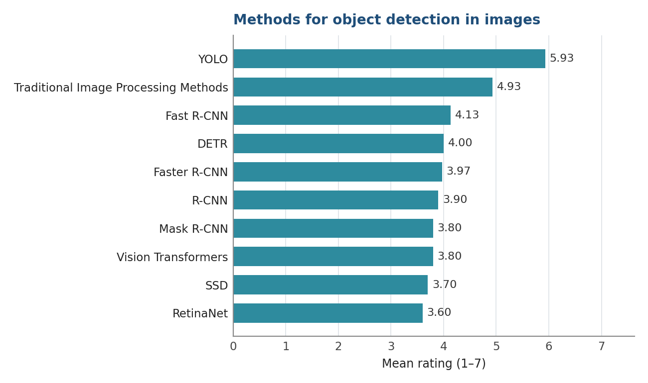
Figure 8. Methods for object detection in images
Semantic segmentation is the weakest sub-area within the image modality: fully convolutional networks lead at 5.07, U-Net reaches only 4.20 and DeepLab 3.50. For pattern and defect recognition, the leading methods are YOLO (5.43), convolutional neural networks (5.30) and transfer learning (5.27).
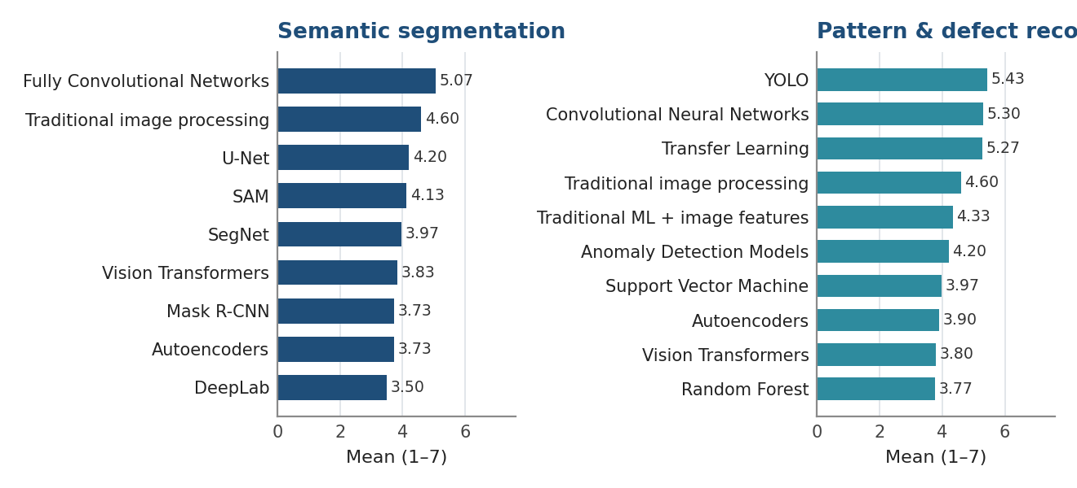
Figure 9. Methods for semantic segmentation and for pattern and defect recognition

6. Audio data
Audio is the least represented modality. Not a single problem type exceeds a rating of 4.03, and no individual method exceeds 4.20. Sound classification and speech recognition are tied at 4.03, while anomaly detection in audio (3.07) and speech emotion recognition (2.87) are the two lowest-rated problem types in the whole survey.
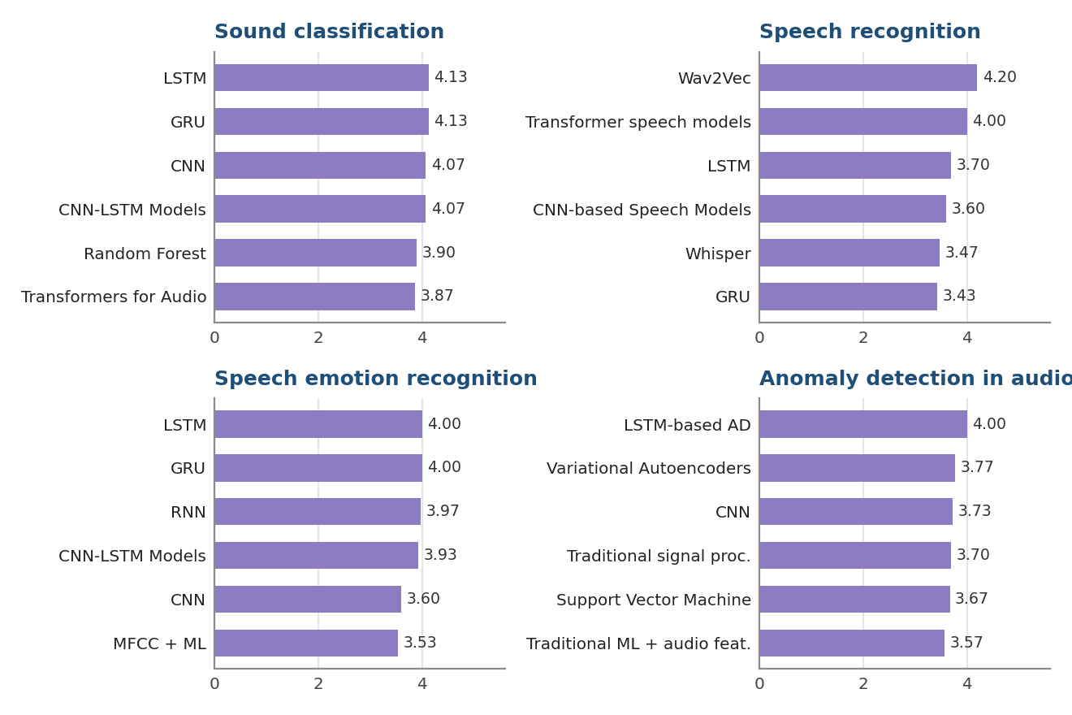
Figure 10. Highest-rated methods for the four audio problem types
Within this modality, recurrent architectures (LSTM and GRU, both 4.13) and CNN-based models are rated slightly higher than classical MFCC-based approaches (3.40). Notably, Wav2Vec (4.20) is rated above Whisper (3.47), even though Whisper is the more widely used tool. This shows that the field is known mainly at the conceptual level rather than through hands-on use.

7. Video data
Regarding video data two problem types clearly stand out: video classification and action recognition (4.50) and object detection in video (4.30), while video segmentation (3.27) and video captioning (3.17) attract less interest. Across all four tasks the same combination recurs at the top CNN combined with a recurrent network (4.10 to 4.27) and 3D or spatio-temporal convolutional networks (3.53 to 4.07).
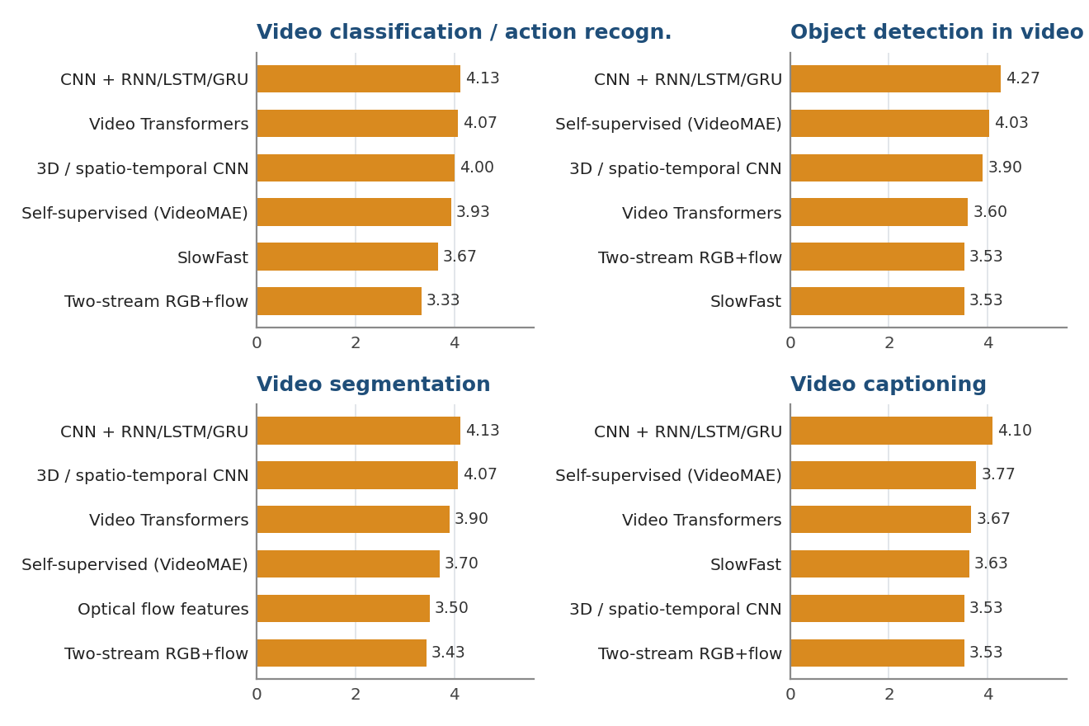
Figure 11. Highest-rated methods for the four video problem types
Video transformers and self-supervised pretrained models such as VideoMAE are rated evenly across all four tasks (around 3.6 to 4.1), which suggests recognition of their potential rather than established practice.

8. Priority of teaching modules
All ten proposed modules received a mean rating above 4.8.
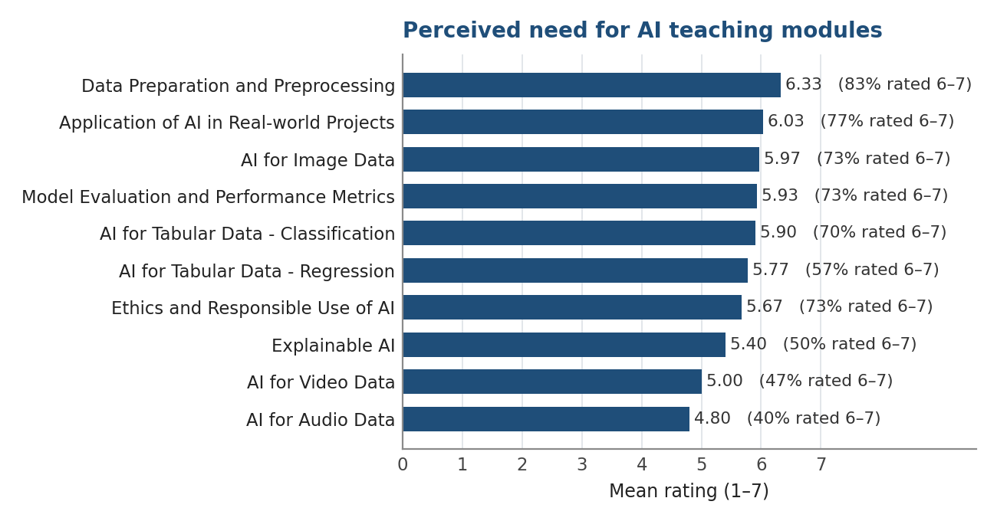
Figure 12. Perceived need for individual teaching modules (mean rating and share of ratings 6–7)
Data preparation and preprocessing is the highest-rated module (6.33), with 83 % of respondents rating it 6 or 7 and with the smallest dispersion of all items (SD = 1.09) — this is the one point on which the sample is essentially unanimous. It is followed by the application of AI in real-world projects (6.03), AI for image data (5.97), model evaluation and performance metrics (5.93) and classification on tabular data (5.90).
Mean rating of Ethics and Responsible Use of AI is 5.67 and it is in the middle of the ranking, but 73 % of respondents rated it 6 or 7. It is also the only module rated practically identically by senior and junior staff (5.65 versus 5.69 respectively), whereas for most other modules senior staff give ratings roughly one point higher.
The two lowest-ranked modules are AI for video data (5.00) and AI for audio data (4.80), consistent with the low ratings for those modalities in Sections 6 and 7.
Table 1. Ranking of teaching modules by perceived need
Teaching module | Mean | SD | % rated 6–7
Data Preparation and Preprocessing | 6.33 | 1.09 | 83 %
Application of AI in Real-world Projects | 6.03 | 1.50 | 77 %
AI for Image Data | 5.97 | 1.27 | 73 %
Model Evaluation and Performance Metrics | 5.93 | 1.48 | 73 %
AI for Tabular Data – Classification | 5.90 | 1.18 | 70 %
AI for Tabular Data – Regression | 5.77 | 1.22 | 57 %
Ethics and Responsible Use of AI | 5.67 | 1.27 | 73 %
Explainable AI | 5.40 | 1.25 | 50 %
AI for Video Data | 5.00 | 1.46 | 47 %
AI for Audio Data | 4.80 | 1.49 | 40 %

9. Level, teaching materials and tools
The preferred level of the modules is intermediate (13 of 30 respondents), with a further 8 preferring a combination of basic, intermediate and advanced levels. Only 3 respondents opted exclusively for the advanced level. In practice this means that a single-level design would not serve the group well: the material should be built at an intermediate baseline with an accessible entry point and optional advanced extensions.
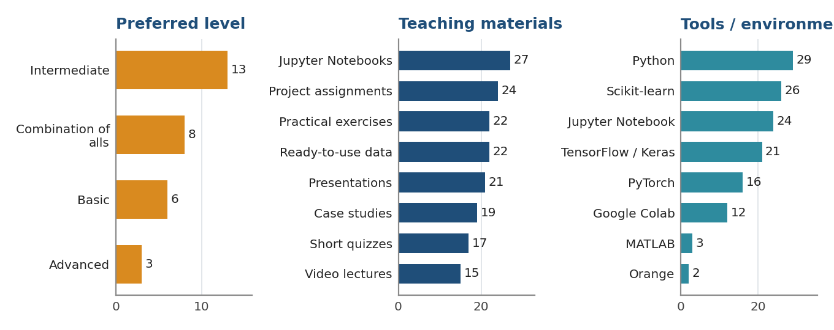
Figure 13. Preferred level, types of teaching material and software tools in use
Among types of teaching material, Jupyter Notebook examples are the clear leader (27 of 30), followed by project assignments (24), practical exercises (22) and ready-to-use datasets (22). Video lectures are the least requested format (15). The message is unambiguous: the modules should be executable and hands-on rather than lecture-based.
The tool ecosystem is homogeneous and requires no compromise: Python (29), scikit-learn (26), Jupyter Notebook (24), TensorFlow/Keras (21) and PyTorch (16). Google Colab is used by 12 respondents, MATLAB by 3 and Orange by 2. A Python-based technology stack is therefore a safe and non-controversial choice for all materials.

10. Open-ended suggestions
The response rate to the open-ended questions was low, but the suggestions received consistently concern methods not offered in the closed lists:
- Regression: Gaussian processes (rated 6), ordinary least squares (7), quantile regression (4).
- Time series: naive and baseline models — random walk, seasonal naive (6) — as a reference point for evaluation.
- Clustering: spectral clustering (6), k-modes and k-prototypes for categorical data (5).
- Images: DenseNet (7), vision–language models (6), self-supervised and contrastive learning such as SimCLR and BYOL, and high-resolution networks (5) for segmentation.
- Audio and defect recognition: WaveNet and 1D temporal convolutional networks (5), multimodal anomaly detection (5).
The suggestion of baseline models for time series is worth highlighting: it comes from the same logic as the emphasis on data preparation and on evaluation metrics, that the weak point of practice lies not in the choice of the most advanced model but in the methodological framework around it.

11. Recommendations for the development of the TAI modules
The survey results provide basis for the development of the TAI MOOC. The course should primarily focus on AI applications involving tabular and image data, particularly classification, regression, image classification and object detection. At the same time, the findings show that the greatest educational need concerns methodological foundations, including data preparation, preprocessing, model evaluation, experimental design and the interpretation of results. The MOOC should therefore begin with a common methodological core before introducing modality-specific content. Ethics, responsible AI and explainability should be integrated throughout the course through practical examples rather than treated only as separate theoretical topics. The preferred delivery approach is an intermediate-level, hands-on format based on Python, Jupyter Notebooks, practical exercises, ready-to-use datasets and project assignments. Introductory explanations and optional advanced sections should be included to accommodate participants with different levels of prior knowledge. Audio and video topics may be covered in shorter units, while tabular and image data should receive the largest share of the course. The consistency of the responses provides a sufficiently strong basis for defining the initial structure, content and delivery format of the MOOC.

Appendix - Questionnaire



Lead Partner

Partners






